GeoZK-Miner: A Privacy-Preserving Blockchain Framework for Ethical Mineral Provenance and Reacquisition Governance

1. Introduction

1.1 Background
The extraction and trade of conflict minerals, particularly tin, tungsten, tantalum, and gold, commonly known as 3TG minerals, together with increasingly important minerals such as cobalt, remain major challenges in global supply-chain governance. These minerals are essential for modern technologies, including electronics, electric vehicle batteries, renewable energy systems, communication devices, and defence-related equipment. However, many of these resources are sourced from conflict-affected and high-risk areas (CAHRAs), where mining activities may be linked to armed groups, illegal taxation, forced labour, unsafe working conditions, corruption, environmental damage, and human rights violations [1].
Because of these risks, conflict mineral traceability is not simply a technical issue. It is also an ethical, regulatory, and governance issue. Companies need to prove that their minerals are responsibly sourced, while regulators and consumers increasingly expect stronger evidence of ethical supply-chain behaviour. Frameworks such as the OECD Due Diligence Guidance, the U.S. Dodd-Frank Act, and the EU Conflict Minerals Regulation have pushed organisations to improve mineral origin reporting, risk assessment, supplier auditing, and public disclosure [2], [3]. These regulatory developments show that the mineral supply chain needs reliable systems that can verify origin, support accountability, and reduce the risk of fraudulent or unethical sourcing [4].
Despite these efforts, existing mineral traceability systems still face serious limitations. Traditional systems, such as manual bag-and-tag approaches, often depend on paper-based records, manual inspection, physical tags, and delayed reporting [5]. These methods are vulnerable to human error, corruption, document manipulation, tag misuse, and cross-border mineral laundering. In many cases, traceability evidence becomes available only after several stages of the supply chain have already been completed [5], [6]. This weakens real-time accountability and makes it difficult for downstream actors such as smelters, manufacturers, and auditors to identify problematic batches quickly.
At the same time, full transparency can create another problem. In conflict-affected regions, publishing exact mine coordinates, supplier relationships, transport routes, or commercial agreements may expose mining communities and companies to security risks [8]. For example, if exact mining locations are publicly revealed, illegal armed groups, smugglers, or competitors may misuse that information. Therefore, the conflict mineral sector faces a difficult balance: it must provide enough transparency to prove ethical origin, but it must also protect sensitive operational and geographic information.
This creates the main motivation for this study. A practical conflict mineral traceability system should not only record mineral movement on a tamper-resistant ledger. It should also allow stakeholders to verify important claims without forcing them to reveal sensitive data. Blockchain can provide an immutable and auditable record of mineral batch events, while zero-knowledge proofs (ZKPs) can allow a party to prove that a mineral batch satisfies a required condition without revealing the private data behind that condition [8], [10], [11].

1.2 Problem Statement
Current conflict mineral traceability systems face a fundamental privacy–transparency paradox. On one side, regulators, manufacturers, and consumers need evidence that minerals are sourced from approved and ethical regions. On the other side, mining actors may need to protect exact geographic coordinates, supplier identities, and commercially sensitive relationships [8], [11]. Traditional traceability systems often fail to solve this problem because they either depend on manual trust-based reporting or reveal too much information to too many parties.
Existing blockchain-based traceability systems improve tamper resistance by recording transactions on distributed ledgers [9]. However, many blockchain systems still store supply-chain information in visible, hashed, or permissioned forms that may reveal transaction patterns, supplier links, and operational details. Hashing alone does not fully solve the privacy problem because the system may still expose relationships between actors or require sensitive data to be disclosed during verification [8], [10]. Therefore, a stronger privacy-preserving mechanism is needed.
Another major limitation is the lack of automated mineral reacquisition governance. In real supply chains, a mineral batch may need to be returned, rejected, withdrawn, or placed under audit because of quality problems, certification concerns, ethical sourcing doubts, or regulatory inspection findings. Current systems often handle these cases manually through document review, bilateral communication, and delayed approval procedures [5], [6]. This creates inefficiency and makes it difficult to remove non-compliant batches from the supply chain quickly.
To address these gaps, this paper proposes GeoZK-Miner, a privacy-preserving blockchain framework for ethical mineral provenance and reacquisition governance. The key idea is to allow a mining actor to prove that a mineral batch originates from an auditor-approved geographic region without revealing the exact mining coordinates. The framework uses a region-based zero-knowledge proof to verify geographic compliance, while Ethereum smart contracts manage stakeholder roles, batch registration, custody progression, proof verification, reacquisition requests, and auditor decisions [8], [10], [11]. In the current prototype, certification information is represented through cryptographic commitments or hashes, while full ZKP-based certification validation is identified as a future extension.

1.3 Research Questions
This study addresses the following research questions:
RQ1: How can a region-based zero-knowledge proof mechanism verify that a mineral batch originates from an approved region without revealing the exact mine coordinates?
RQ2: How can smart contracts support role-based mineral provenance tracking, custody progression, and reacquisition governance in a conflict mineral supply chain?
RQ3: What are the implementation costs and performance characteristics of a blockchain-based mineral provenance system that integrates zero-knowledge region verification?

1.4 Contributions
This paper presents GeoZK-Miner, a blockchain and zero-knowledge proof-based framework for privacy-preserving conflict mineral provenance and reacquisition governance. The main contributions are as follows.
First, this study proposes a region-based zero-knowledge proof model for conflict mineral origin verification. Instead of revealing exact GPS coordinates, a mining actor proves that the private location data belongs to an auditor-approved region. This supports ethical origin verification while protecting sensitive geographic information [8], [11].
Second, the paper develops a smart contract-based provenance framework for mineral batch lifecycle management. The framework records key events such as stakeholder registration, region approval, mineral batch creation, ZKP verification, lifecycle status updates, and reacquisition resolution through blockchain events [9], [10].
Third, the study introduces a reacquisition governance mechanism for mineral batches. Smelters or manufacturers can request reacquisition when a batch raises quality, compliance, or ethical concerns, while an auditor can approve, reject, or mark the batch for further audit. This creates a structured and auditable process for handling problematic mineral batches.
Fourth, the paper implements a working prototype using Solidity, Hardhat, Ethereum-style smart contracts, Circom, snarkjs, and the Groth16 proving system. The implemented prototype demonstrates region-based ZKP verification, role-based access control, batch lifecycle tracking, reacquisition handling, gas measurement, and event-log export.
Fifth, the study provides an implementation-based evaluation using local Hardhat experimental results. The evaluation reports gas usage, transaction latency, throughput, deployment cost, and event-log evidence for major operations such as batch creation, lifecycle update, reacquisition request, and proof-based batch verification.

1.5 Paper Organization
The remainder of this paper is organized as follows. Section 2 reviews existing work on traditional conflict mineral traceability systems, blockchain-based mineral provenance, zero-knowledge proofs in supply chains, and reacquisition-related governance gaps. Section 3 presents the proposed GeoZK-Miner framework, including the system architecture, actors, region-based ZKP model, mineral batch lifecycle, and reacquisition governance process. Section 4 describes the implementation environment, smart contracts, ZKP circuit design, experimental setup, gas analysis, and event-log-based results. Section 5 discusses the benefits, limitations, security implications, and real-world deployment challenges of the framework. Section 6 concludes the paper and outlines future research directions.

2. Related Work

2.1 Traditional Traceability Systems
The predominant approach to conflict mineral traceability relies on manual and semi-digital documentation systems, most notably the International Tin Supply Chain Initiative (iTSCi). Established to support responsible sourcing and due diligence in conflict-affected and high-risk areas, iTSCi operates through a “bag-and-tag” model in which mineral bags are physically sealed, tagged, and recorded through documentation processes [6]. Although this approach has contributed to upstream mineral traceability, it remains vulnerable to operational weaknesses, including manual data entry errors, delayed reporting, tag misuse, corruption risks, and cross-border misreporting [5], [6].
The European Parliament’s study on critical raw material traceability highlights that upstream traceability in African mineral supply chains remains difficult because of fragmented actors, artisanal and small-scale mining conditions, weak infrastructure, and the practical limitations of chain-of-custody systems [5]. These problems are particularly significant in conflict mineral contexts, where the reliability of the first data entry point is essential. If the original mine-site record is incorrect, manipulated, or fraudulently tagged, later digital traceability cannot fully repair the integrity of the supply chain. This creates a serious limitation for manual schemes because they depend heavily on human reporting and institutional trust.
The OECD Due Diligence Guidance provides an internationally recognised framework for responsible mineral sourcing, requiring companies to establish management systems, identify and assess risks, design risk responses, conduct audits, and publicly report on due diligence practices [2]. However, the OECD framework does not prescribe a specific technical implementation for real-time verification, privacy-preserving origin validation, or automated reacquisition governance. As a result, many mineral traceability systems still depend on paper documents, centralised databases, human audits, and delayed certification checks. These limitations create the need for more tamper-resistant and privacy-aware digital systems.

2.2 Blockchain-Based Mineral Traceability Systems
Blockchain-based traceability systems have been introduced to address the weaknesses of centralised and paper-based mineral supply-chain records. By providing tamper-resistant transaction records, blockchain can improve transparency, provenance tracking, and auditability across multiple supply-chain actors [9]. In mineral supply chains, several industry initiatives have explored blockchain for responsible sourcing, including Minespider, Circulor, and the Responsible Sourcing Blockchain Network (RSBN).
Minespider has developed blockchain-based tools for responsible mineral tracking, including OreSource, which has been piloted with LuNa Smelter, Google, and Rwanda-based mining stakeholders to support mineral traceability and compliance with responsible sourcing requirements [15], [16]. Similarly, Circulor has demonstrated blockchain-based mine-to-manufacturer traceability for tantalum from Rwanda using a permissioned blockchain infrastructure [17]. IBM’s RCS Global case study also shows how blockchain can support responsible sourcing by recording provenance information, certificates of responsible production, and supply-chain data in a tamper-resistant environment [18].
Although these systems represent important progress, they do not fully solve the privacy–transparency paradox in conflict mineral sourcing. Many blockchain-based mineral systems improve traceability but still rely on permissioned access, authorised data sharing, or conventional verification of supplier information. This means that sensitive information, such as supplier relationships, operational details, or mine-location data, may still need to be exposed to selected actors. For conflict-affected mining regions, this creates security and commercial risks. Existing systems therefore show the value of blockchain for traceability, but they do not provide a complete cryptographic mechanism for proving regional mineral origin without revealing exact mine coordinates.

2.3 Zero-Knowledge Proofs in Supply Chain Applications
Zero-knowledge proofs (ZKPs) have emerged as a promising cryptographic technique for solving the privacy–transparency conflict in blockchain-based systems. A ZKP allows one party to prove that a statement is true without revealing the underlying private data. This is highly relevant for supply chains because stakeholders often need to verify claims about origin, compliance, quality, or authenticity without exposing confidential operational information.
Sahai et al. proposed a blockchain-based supply-chain model that uses ZKPs and cryptographic accumulators to support both privacy and traceability, showing that ZKPs can be used to verify supply-chain claims without exposing complete product histories [10], [14]. Similarly, Malik et al. introduced PrivChain, a blockchain-enabled privacy-preserving provenance framework that uses ZKPs to protect sensitive supply-chain data while still enabling verification and traceability [8], [13]. These works demonstrate that ZKPs can support privacy-preserving provenance in general supply-chain settings.
However, ZKP applications specifically designed for conflict mineral traceability remain limited. Existing ZKP-based supply-chain studies are mostly general-purpose and do not directly address the special requirements of mineral sourcing, such as conflict-free origin verification, geographic privacy, mine-site security, CAHRA compliance, and batch rejection governance. The seafood-focused BT-CSRS framework also uses blockchain and ZKPs, but its focus is seafood sustainability, catching validation, cold-chain handling, and seafood reacquisition rather than conflict mineral origin privacy or regional mine verification [12]. Therefore, there remains a clear research gap for a mineral-specific ZKP framework that can verify whether a batch originates from an approved region without revealing precise mine coordinates.

2.4 Research Gap Summary
The reviewed literature shows that traditional traceability systems, blockchain-based mineral platforms, and ZKP-enabled supply-chain models each address part of the problem, but none fully solves the combined challenge of privacy-preserving conflict mineral provenance and reacquisition governance. Traditional systems such as iTSCi support upstream due diligence but remain dependent on manual records and institutional trust [5], [6]. Blockchain-based systems such as Minespider, Circulor, and RSBN improve traceability and tamper resistance but do not provide a mineral-specific zero-knowledge mechanism for confidential region-based origin verification [15]–[18]. General ZKP supply-chain frameworks demonstrate privacy-preserving provenance, but they are not designed around conflict minerals, mine-location confidentiality, or mineral batch reacquisition [8], [10], [13], [14].
To clearly position the proposed framework against existing systems, Table 1 compares traditional traceability schemes, blockchain-based mineral platforms, ZKP-enabled supply-chain models, and the proposed GeoZK-Miner framework. The comparison focuses on whether each approach supports blockchain-based traceability, privacy-preserving verification, ZKP integration, end-to-end mineral provenance, and reacquisition or return automation. This comparison helps to highlight the specific research gap addressed by GeoZK-Miner: the integration of region-based ZKP verification, blockchain-based mineral provenance, and smart contract-based reacquisition governance within one conflict mineral framework.

Table 1
Comparative Analysis of Existing Traceability Approaches and the Proposed GeoZK-Miner Framework
Approach / Study | Main Focus | Blockchain Support | Privacy-Preserving Verification | ZKP Integration | End-to-End Mineral Traceability | Reacquisition / Return Automation | Key Limitation
iTSCi / bag-and-tag schemes [6] | Upstream 3TG mineral traceability and due diligence | No | No | No | Partial | No | Depends on manual tagging, paper-based records, and institutional trust; vulnerable to delayed reporting, corruption, and cross-border misreporting.
Circulor [17] | Mine-to-manufacturer traceability for conflict minerals and battery materials | Yes | Limited | No explicit ZKP support | Partial to broad | No explicit support | Improves digital traceability, but does not provide cryptographic proof of mineral origin without exposing sensitive location or supply-chain data.
Minespider / OreSource [15], [16] | Digital mineral traceability, compliance support, and product passport-style documentation | Yes | Limited | No explicit ZKP support | Partial to broad | No explicit support | Provides strong digital recordkeeping, but lacks a mineral-specific region-based ZKP model for confidential origin verification.
IBM / RCS Global / RSBN [18] | Responsible mineral sourcing and blockchain-based provenance sharing | Yes | Permissioned sharing | No explicit ZKP support | Broad | No explicit support | Supports validated data exchange and responsible sourcing records, but does not address region-private origin proof or automated reacquisition governance.
Sahai et al. [10], [14] | Generic privacy and traceability in blockchain-based supply chains | Yes | Yes | Yes | Not mineral-specific | No | Demonstrates ZKP feasibility in supply chains, but does not focus on conflict mineral origin privacy, CAHRA compliance, or reacquisition handling.
PrivChain / Malik et al. [8] | Privacy-preserving provenance in blockchain-enabled supply chains | Yes | Yes | Yes | Not mineral-specific | No | Protects sensitive supply-chain data, but is not designed for mineral-specific region verification or disputed batch reacquisition.
BT-CSRS / Rani et al. [12] | Seafood traceability and seafood reacquisition using blockchain and ZKPs | Yes | Yes | Yes | No | Yes, for seafood | Focuses on seafood catching, sustainability, and reacquisition; it does not address conflict minerals, mine-location privacy, or ethical mineral governance.
GeoZK-Miner (this work) | Conflict mineral provenance, region-based origin verification, and reacquisition governance | Yes | Yes | Yes | Yes | Yes | Addresses the missing combination of region-based ZKP origin verification, blockchain-based mineral provenance, and smart contract-based reacquisition governance.

3. Proposed Framework: GeoZK-Miner

3.1 System Architecture and Actors
GeoZK-Miner adopts a three-layer architectural model consisting of the Physical Layer, Cryptographic Layer, and Ledger Layer. This design addresses the central privacy–transparency challenge in conflict mineral sourcing. Regulatory and industrial stakeholders require evidence that a mineral batch originates from an approved and ethically compliant region, while mining actors operating in conflict-affected or high-risk areas may need to protect exact geographic coordinates for security and commercial reasons [2], [5], [11].
The Physical Layer represents the real-world mineral supply-chain environment. It includes mine sites, mining cooperatives, logistics providers, smelters, manufacturers, and auditors. At this layer, mineral batches are created, moved, processed, disputed, and potentially reacquired. The mine site or cooperative collects minimum batch information, such as mineral type, batch identifier, extraction date, certification hash, and private location coordinates. However, exact GPS coordinates are not published directly to the blockchain. Instead, the raw geographic information remains off-chain and is used only as private input for the region-based ZKP process.
The Cryptographic Layer provides privacy-preserving verification. In this layer, the mining actor generates a zero-knowledge proof showing that the private extraction coordinates fall inside an auditor-approved region. The proof allows the system to answer the compliance question “Does this batch originate from an approved region?” without answering the sensitive question “What is the exact mine location?” This layer uses a region commitment, a public approved-region hash, and a ZKP verification process. The prototype implementation uses Circom and snarkjs with Groth16 over the BN254/alt_bn128 curve family, which is commonly used for Ethereum-compatible zk-SNARK verification. Recent work on zero-knowledge location privacy also shows that geographic claims can be proven without revealing exact location data, supporting the technical direction of region-based verification [11].
The Ledger Layer records verified supply-chain events using Ethereum-style smart contracts. This layer stores non-sensitive metadata, cryptographic commitments, approved region hashes, lifecycle states, and reacquisition decisions. Smart contracts manage stakeholder registration, mineral batch creation, proof verification, custody progression, reacquisition requests, and auditor decisions. This creates a tamper-evident audit trail without exposing sensitive mine coordinates or full private documentation. Smart contracts are widely used in traceability systems because they support rule-based state transitions, event logging, and automated verification on Ethereum-compatible infrastructures [18].
The system includes five main actors. The Mining Cooperative or Mine Site creates mineral batches and generates region-based ZKPs proving that private origin coordinates fall inside an approved region. The Logistics Provider records transport or custody progression events as the batch moves through the supply chain. The Smelter or Refiner processes mineral batches and may request reacquisition when quality, provenance, or compliance concerns arise. The Manufacturer verifies the downstream status of mineral batches before final product integration. The Auditor or Regulatory Authority approves region hashes, validates submitted proofs, and resolves reacquisition cases through approval, rejection, or further audit.
As illustrated in Fig. 1, the workflow begins when an auditor approves a region hash and a mine site creates a mineral batch with non-sensitive metadata and cryptographic commitments. The mining actor then generates a region-based zero-knowledge proof using private location inputs. The proof and public signals are submitted to the smart contract for verification. If verification succeeds, the batch is recorded as ZKP-verified and can continue through logistics, smelting, and manufacturing stages. If a downstream actor later identifies a quality, provenance, or compliance concern, the reacquisition workflow is triggered and resolved by the auditor. This structure allows GeoZK-Miner to combine privacy-preserving origin verification, blockchain-based provenance tracking, and smart contract-based reacquisition governance.
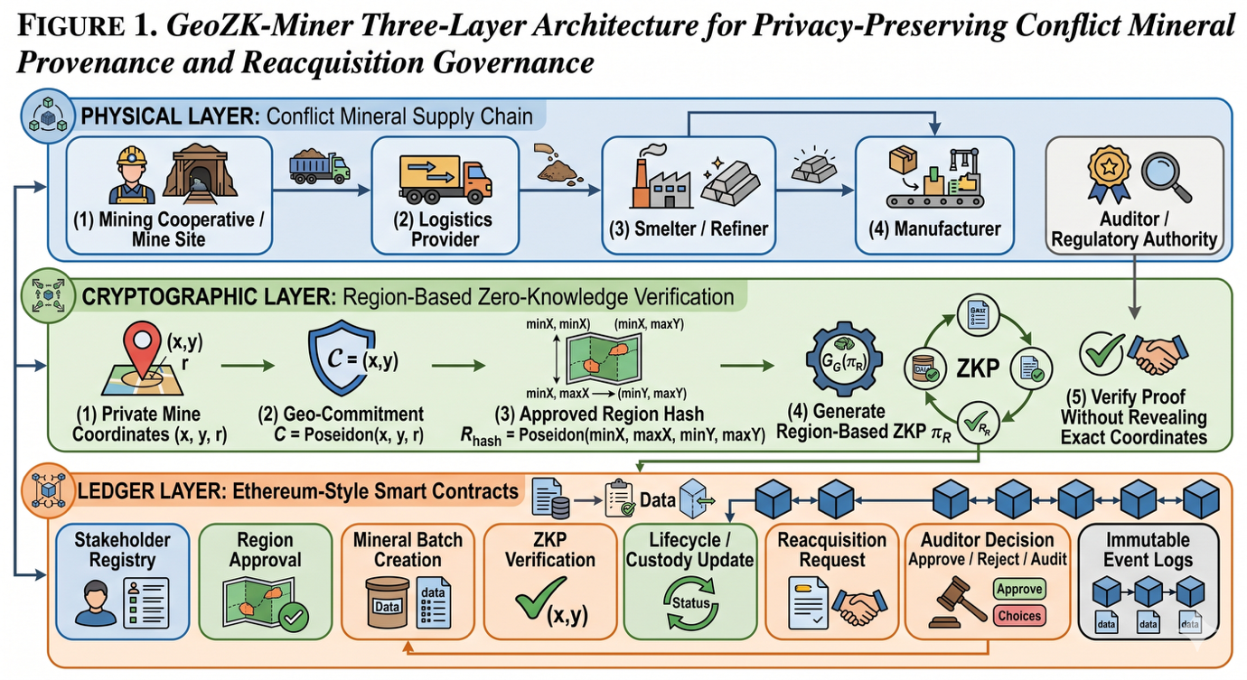
To formalize the overall workflow of the proposed system, Algorithm 1 presents the GeoZK-Miner workflow for conflict mineral provenance and reacquisition governance. The algorithm begins with stakeholder registration and smart contract deployment, followed by region approval, mineral batch creation, ZKP-based regional provenance verification, lifecycle tracking, and auditor-controlled reacquisition handling.

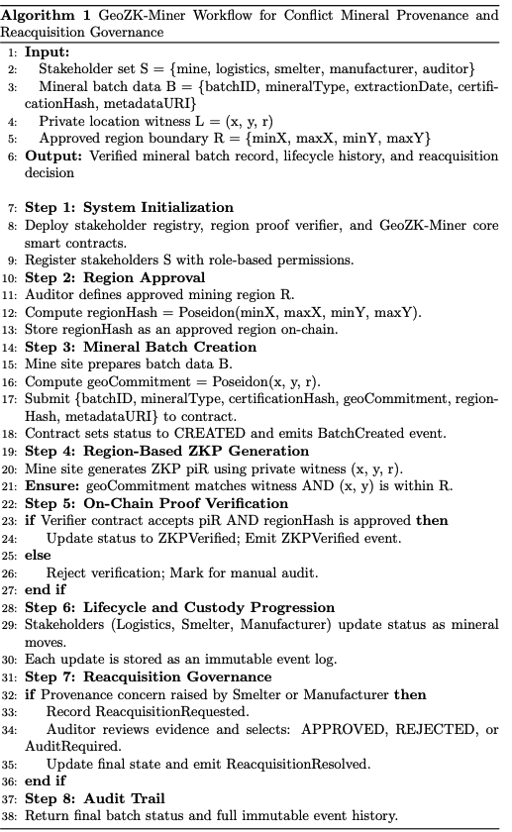

3.2 Region-Based ZKP Scheme
The core novelty of GeoZK-Miner lies in its region-based zero-knowledge proof scheme, which allows a mining actor to prove that a mineral batch originates from an approved region without revealing exact mine coordinates. This design directly addresses the privacy–transparency paradox in conflict mineral sourcing. Conventional traceability requires evidence of origin, but publishing exact coordinates or detailed route data may create security risks for mine operators and expose commercially sensitive information [5], [11]. Recent work on zero-knowledge location privacy shows that geographic predicates can be proven without disclosing precise location data, supporting the technical direction of privacy-preserving region verification [11].
This makes such an approach particularly suitable for conflict mineral systems where the required compliance question is often “Is this batch from an approved region?”, not “What is the exact coordinate of the mine?”
Let the mine location be denoted by the private coordinate pair
$$L=(x,y)$$where $x$and $y$represent the latitude and longitude of the extraction site. Let $R$denote an approved certification region defined as a bounded polygon or administrative area:
$$R=\{(x,y)∣(x,y)\text{ lies within certified region}\}.$$
The compliance statement to be proven is:
$$S:L∈R.$$Instead of disclosing $L$, the mining actor computes a commitment:
$$C=\text{Com}(L,r)$$
where $r$is random blinding data and $\text{Com}(⋅)$is a commitment function that binds the prover to the location without revealing it. The prover then generates a zero-knowledge proof $π_{R}$such that:

$$π_{R}←\text{Prove}\left(L,r,R\right)$$
and the verifier checks:
$$\text{Verify}(C,π_{R},R)=1.$$
If verification returns true, the smart contract accepts that the batch originates from an approved region, even though the exact location remains confidential. This design aligns with privacy-preserving provenance literature showing that ZKPs can protect sensitive supply-chain information while still enabling verification [8], [10]. However, GeoZK-Miner applies this logic specifically to conflict minerals by anchoring proof generation to approved geographic regions rather than exposing exact mine coordinates.The same structure can be extended to certification validation. Let $E$denote a certification status variable such that:
$$E∈\{0,1\}$$
where $E=1$means the batch is associated with a valid ethical or regulatory certification. A second proof $π_{E}$may be generated to show that the batch satisfies certification constraints without exposing the full certification file or intermediary details:
$$\text{Verify}(C_{E},π_{E})=1.$$
In the implemented GeoZK-Miner prototype, the ZKP component verifies region compliance, while certification information is represented through a cryptographic hash or commitment. Full ZKP-based certification validation can be added as a future extension, but it is not claimed as part of the current implemented verification path.. In practice, the mining actor provides proof that the batch is both region-compliant and certification-compliant, while the blockchain stores only commitments, proof outputs, timestamps, and lifecycle state changes. Sensitive data remain off-chain. This architecture is also consistent with recent smart-contract-based traceability literature showing that smart contracts are effective for process automation and tamper-evident traceability, while privacy-preserving layers are needed to avoid overexposure of business-critical data [18], [19].
Proving system: Groth16 zk-SNARK.
Circuit framework: Circom with snarkjs.
Curve family: BN254/alt_bn128 for Ethereum-compatible verification.
Proof statement: private coordinates lie within an approved region and match the public geographic commitment.
Certification handling: certification hash/commitment stored on-chain; full certification ZKP is future work.

3.3 ZKP-Based Mineral Extraction Process
The mineral extraction stage is the first trusted entry point of the proposed framework. At this stage, the mine site or cooperative collects the minimum required data for traceability, including batch ID, mineral type, extraction date, and certification status. These attributes are necessary because responsible mineral supply chains depend on clear linkage between extracted material and subsequent transformations in the chain [12], [13]. Unlike conventional systems, GeoZK-Miner does not write all raw upstream data directly to the blockchain. Instead, the framework stores non-sensitive metadata, approved region hashes, certification hashes, and geographic commitments, while sensitive origin coordinates remain off-chain and are used only as private ZKP inputs. This design follows the broader principle of storing minimal verification data on-chain while keeping sensitive operational data off-chain for privacy and scalability [19].As shown in Fig. 2, the extraction process contains four main stages: data collection, proof generation, smart contract verification, and blockchain storage. First, the mine site prepares a batch record. Second, the region-compliance proof is generated locally or through a trusted digital interface.
$$ValidExtract(B_{i})=1⟺Verify(C_{R},π_{R},R)=1∧CertHash_{i}≠∅$$
where $Verify(C_{R},π_{R},R)=1$means that the region proof has been accepted, and $CertHash_{i}$means that a certification commitment or hash has been attached to the batch record. This avoids falsely claiming that certification is ZKP-verified.
Third, the proof package is submitted to the smart contract, which checks whether the batch satisfies the encoded compliance predicates. Finally, once the proof is verified, the batch is stored on-chain with a trusted state such as Registered, Verified, or Flagged. This method draws on the same privacy-preserving logic observed in earlier ZKP-enabled traceability models, but tailors it to mineral extraction where location confidentiality is more sensitive than in ordinary product supply chains [14]–[17].
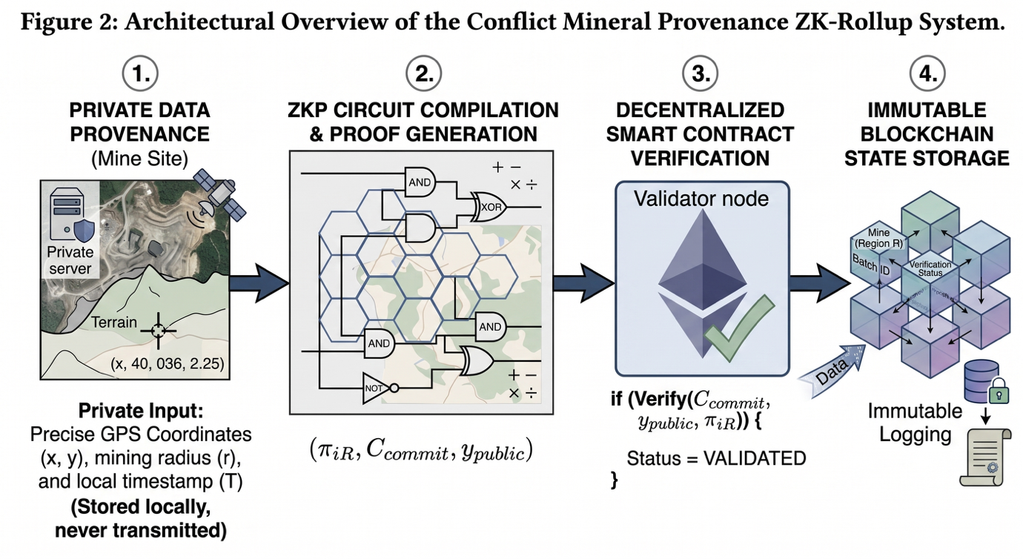
Figure 2. ZKP-based mineral extraction process showing data collection, proof generation, smart contract verification, and blockchain registration.
Formally, let the batch record be:
$$B_{i}=\{ID_{i},M_{i},T_{i},C_{i}\}$$where $ID_{i}$is the batch identifier, $M_{i}$is the mineral type, $T_{i}$is the extraction timestamp, and $C_{i}$is the certification commitment. A valid extraction event occurs if both region and certification proofs are accepted:
$$\text{ValidExtract}(B_{i})=1 ⟺ \text{Verify}(C_{R},π_{R},R)=1∧\text{Verify}(C_{E},π_{E})=1.$$
If this condition holds, the contract records the batch as verified and emits an event to notify downstream actors. Otherwise, the contract rejects the batch or marks it for further audit.
To formalize the extraction-stage workflow of the proposed framework, Algorithm 2 presents the ZKP-based mineral extraction process in GeoZK-Miner.. The algorithm begins by receiving the batch ID, mineral type, extraction date, and certification data as input parameters. It then commits sensitive origin and certification attributes, generates the region-compliance proof $π_{R}$and certification-validity proof $π_{E}$, and submits the resulting metadata, commitments, and proofs to the smart contract. The contract verifies all proofs before making a final decision. If verification succeeds, the mineral batch is registered on-chain as a trusted extraction record; otherwise, the batch is rejected or flagged for further audit.
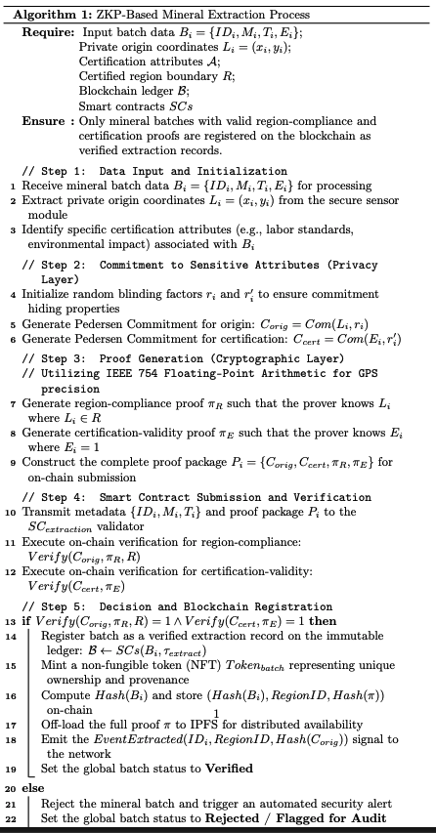

3.4 ZKP-Based Reacquisition Process
In GeoZK-Miner, reacquisition refers to the controlled return, quarantine, re-verification, or withdrawal of a mineral batch after it has entered the supply chain.. This process is triggered by events such as batch rejection, audit failure, or ethical violation. Unlike traditional mineral traceability systems, which mainly focus on forward movement from extraction to processing, the proposed framework explicitly supports reverse decision logic. This is important because disputed or non-compliant batches create significant financial and governance risks if they cannot be isolated and processed efficiently.
As illustrated in Fig. 3, the reacquisition process begins when a smelter, manufacturer, or auditor initiates a dispute over a batch. The initiating actor submits a reacquisition request referencing the batch ID and the relevant compliance concern. The system then generates or retrieves proof that the batch’s origin and certification chain satisfy or fail the necessary conditions. The smart contract evaluates the evidence and automatically issues one of three outcomes: Approve Reacquisition, Reject Reacquisition, or Flag for Audit. This automated decision model extends the broader logic of smart-contract-enabled traceability systems, which use encoded business rules for validation and state transitions [18], [19]. The difference is that GeoZK-Miner integrates reacquisition governance with privacy-preserving regional origin verification, rather than relying only on full disclosure or manual document checking.
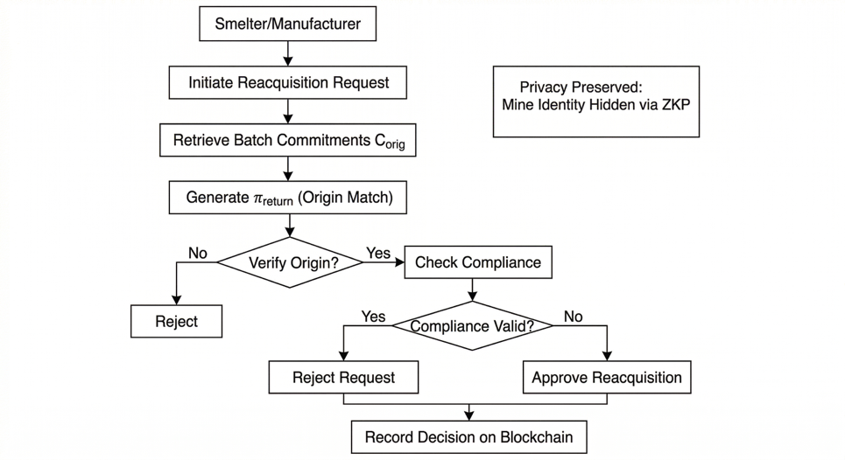
Figure 3. ZKP-based mineral reacquisition process showing dispute initiation, proof submission, contract-based decision, and immutable recording of the outcome.
Let a reacquisition request be represented as:
$$RQ_{i}=\{ID_{i},ρ_{i},τ_{i}\}$$
where $ID_{i}$is the batch identifier, $ρ_{i}$is the reacquisition reason, and $τ_{i}$is the request time. The contract evaluates origin and compliance evidence through:
$$\text{VerifyOrigin}(ID_{i})=1$$and
$$\text{VerifyCompliance}(ID_{i})=1.$$
The decision rule can be written as:
$$D_{i}=\left\{\begin{matrix}\text{Approve}, & \text{if VerifyOrigin}=1∧\text{VerifyCompliance}=0 \\ \text{Reject}, & \text{if VerifyOrigin}=0 \\ \text{Audit}, & \text{otherwise.}\end{matrix}\right.$$
This means that if the origin is valid but compliance has failed, the batch can be formally reacquired or withdrawn. If origin itself cannot be validated, the request is rejected or escalated. If the case is ambiguous, the batch is flagged for further audit. The final decision is written immutably to the blockchain, ensuring that downstream participants can verify the outcome without accessing the private raw evidence.
To formalize the reverse validation workflow, Algorithm 3 presents the ZKP-Based Reacquisition Process adopted in GeoZK-Miner. The algorithm begins by receiving a reacquisition request triggered by batch rejection, audit failure, or ethical violation. It then retrieves the corresponding batch commitments and proof references, generates or resubmits the required origin and compliance proofs, and submits the request to the smart contract for verification. Based on the outcome of proof validation, the contract issues one of three decisions: approve reacquisition, reject reacquisition, or flag the batch for further audit. The final reacquisition status is then immutably recorded on the blockchain.
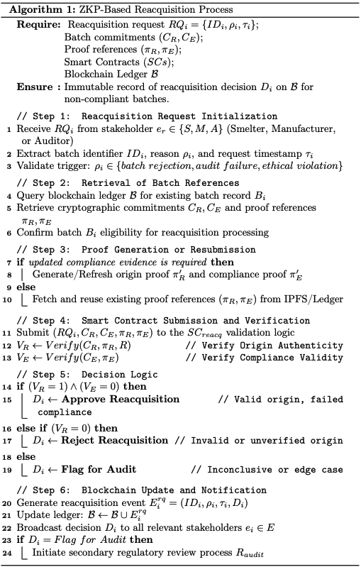

3.5 Security Analysis
The security of GeoZK-Miner depends on three interacting layers: blockchain immutability, smart contract enforcement, and zero-knowledge privacy preservation.. Blockchain-based traceability systems are widely valued because each state transition is recorded in a tamper-evident ledger, making unauthorized modification of past events computationally difficult and operationally visible [18], [19]. In GeoZK-Miner, major events such as batch creation, proof verification, lifecycle updates, reacquisition requests, and auditor decisions are stored as blockchain transactions or emitted events linked to the previous system state. If $H(B_{i})$denotes the hash of block $i$, then:
$$H(B_{i})=\text{Hash}(H(B_{i-1}) ∥ D_{i} ∥ T_{i})$$
where $D_{i}$is the set of recorded transaction data and $T_{i}$is the timestamp. Any attempt to modify a historical batch record changes the block hash and breaks the chain consistency. This provides protection against data tampering and retrospective falsification.
The second layer is smart contract enforcement. Smart contracts encode the rules for stakeholder registration, proof verification, status transition, and reacquisition decisions. This reduces discretionary manipulation by ensuring that only valid proof-bearing transactions can alter the state of a mineral batch. Formally, if $SC(x)$denotes a contract function, then:
$$SC(x)=y\text{only if}x∈\text{ValidDomain}.$$
In other words, a batch state changes only when a submitted transaction satisfies the proof and access conditions defined by the contract.The third layer is zero-knowledge privacy preservation, which addresses unauthorized access and location leakage. Traditional transparent traceability systems may reveal supplier structures, exact mine coordinates, or commercial relationships. In GeoZK-Miner, these are never exposed directly on-chain. Instead, the verifier only sees commitments and proof outputs. As shown in privacy-preserving blockchain literature, such selective disclosure reduces the risk of overexposure while still preserving trust in the verification outcome [14]–[17].
Taken together, this architecture improves resistance against four important risks:
- Data tampering: prevented by immutable blockchain storage and hash-linked records.
- Fake certification injection: reduced through certification hashing, auditor review, and immutable event logging; full ZKP-based certification validation remains a future enhancement. Unauthorized access: limited because sensitive upstream attributes are never disclosed in plaintext.
- Location leakage: mitigated through region-based proof, which verifies compliance without revealing exact coordinates.

From a system perspective, GeoZK-Miner provides a more balanced security model than manual paper-based traceability or plain transparent blockchain systems because it combines integrity, automation, and privacy-preserving regional verification in a single conflict mineral provenance framework
3.6 Threat Model and Security Assumptions
The threat model of GeoZK-Miner is defined around the practical risks that may arise in conflict mineral provenance, region-based proof verification, and reacquisition governance. The model assumes that adversaries may attempt to manipulate digital records, misrepresent mineral origin, misuse stakeholder privileges, or infer sensitive mining locations from public blockchain data. The purpose of this subsection is to clarify what the current prototype is designed to resist and which assumptions remain outside the implemented trust boundary.
The first adversary is a malicious or dishonest mining actor. Such an actor may attempt to register a mineral batch with false provenance data, reuse an old proof, or claim that a batch originates from an approved region when it does not. GeoZK-Miner reduces this risk by requiring the submitted region proof to match both the approved region hash and the geographic commitment stored with the batch. Therefore, a batch cannot be treated as region-verified unless the submitted proof satisfies the verifier logic and the public signals correspond to the recorded batch data [10], [11].
The second adversary is a malicious logistics, smelter, or manufacturer actor. This actor may attempt to update the status of a batch without authorization, move a batch into an invalid lifecycle state, or submit a reacquisition request with misleading information. GeoZK-Miner mitigates this risk through role-based smart contract permissions and state-transition controls. Sensitive actions are restricted to the appropriate stakeholder roles, and state changes are recorded through emitted events, making unauthorized or abnormal workflow behaviour easier to detect during audit review [19], [20].
The third adversary is an external observer of the blockchain. This actor may analyse public transaction data, event logs, commitments, or addresses to infer sensitive supply-chain information. GeoZK-Miner does not publish exact mine coordinates on-chain. Instead, the system stores commitments, approved region identifiers, verification results, and lifecycle events. This design reduces the risk of direct location leakage, although it does not fully eliminate metadata analysis risks such as transaction timing correlation, address clustering, or repeated interaction patterns [8], [10].
The fourth adversary is a compromised or negligent auditor. Since auditors approve region hashes and resolve reacquisition requests, an auditor with malicious intent may approve an unsuitable region or make an incorrect reacquisition decision. The current prototype records auditor actions on-chain, which improves accountability, but it does not fully remove auditor trust. A production deployment should therefore use multi-auditor approval, institutional oversight, or threshold governance for high-risk approvals.
The fifth adversarial scenario is collusion between actors. For example, a mining actor and downstream actor may coordinate to register a questionable batch, move it through the workflow, or dispute it strategically. GeoZK-Miner provides event-level auditability and role-based restrictions, but collusion cannot be fully prevented by smart contracts alone. This limitation is common in digital traceability systems because the blockchain can secure recorded data, but it cannot independently guarantee the honesty of all off-chain physical actions.
Several security assumptions are therefore made. First, the cryptographic hash and commitment functions are assumed to be collision resistant. Second, the Groth16 verifier and generated verification key are assumed to be correctly produced and not maliciously substituted. Third, private witness values used for proof generation are assumed to be protected by the mining actor or trusted local system. Fourth, administrator and auditor keys are assumed to be securely managed. Fifth, the physical mineral batch is assumed to be correctly linked to its digital batch identifier at the point of registration. If any of these assumptions fail, the security guarantees of the implemented prototype may be weakened.
The current prototype also has explicit trust boundaries. It verifies regional compliance through ZKP, but it does not fully verify certification validity through the main ZKP path. Certification data are represented through a hash or commitment, while complete certification-chain proof remains future work. Similarly, the prototype creates an auditable digital record, but it does not by itself prevent physical batch swapping, mineral mixing, or tampering before data entry. These limitations indicate that GeoZK-Miner should be viewed as a privacy-preserving provenance and governance layer that must be combined with reliable physical inspection, secure tagging, and institutional oversight in real-world deployment.

3.7 Smart Contract Security Analysis
The smart contract security of GeoZK-Miner is analysed through access control, proof binding, state-transition enforcement, reentrancy protection, event integrity, and residual implementation risks. This analysis is important because the framework depends not only on ZKP generation, but also on the correctness of the on-chain rules that control batch creation, region approval, proof verification, lifecycle updates, reacquisition requests, and auditor decisions. Smart contracts can improve traceability and automation, but weak authorization or invalid transition logic can create permanent governance weaknesses [19], [20].
Access control is enforced through the stakeholder registry and role-dependent contract functions. Operational roles such as mine, logistics provider, smelter, manufacturer, and auditor are assigned to blockchain addresses. Sensitive actions are then restricted according to these roles. For example, region approval and reacquisition resolution are auditor-controlled actions, while batch creation is linked to mining actors and reacquisition requests are initiated by downstream actors such as smelters or manufacturers. This reduces the risk of arbitrary users approving regions, registering fraudulent batches, or closing disputes without authorization.
Proof verification is protected through binding checks between the submitted proof, the approved region, and the stored batch commitment. The contract does not accept a proof only because the verifier returns a valid result; the proof must also match the batch’s geographic commitment and auditor-approved region hash. This prevents a proof generated for one batch or region from being reused to validate another batch.
GeoZK-Miner also enforces lifecycle-based state transitions. A batch must be created before it can be verified, and verification must occur before downstream lifecycle progression. Reacquisition is allowed only when an authorized downstream actor raises a request. This reduces invalid workflow shortcuts and supports a more reliable provenance history. Reentrancy protection is also applied to sensitive state-changing functions, strengthening the contract logic against repeated or nested calls during critical updates.
Event integrity supports auditability. Events such as BatchCreated, ZKPVerified, BatchStatusUpdated, ReacquisitionRequested, and ReacquisitionResolved allow auditors to reconstruct the lifecycle of a mineral batch from creation to verification, downstream progression, dispute initiation, and final resolution. However, blockchain events record what the contract accepted; they do not independently prove that the physical mineral batch was not swapped, mixed, or mislabelled outside the digital system.
Some residual risks remain. Public blockchain metadata may reveal actor addresses, transaction timing, workflow frequency, and business relationships even when exact mine coordinates remain private. A compromised auditor may also approve an invalid region or resolve a dispute incorrectly. In addition, the current implementation verifies regional compliance through ZKP, while certification data are represented through hashes or commitments. Full ZKP-based certification validation remains future work and should include certificate-specific circuits, auditor signatures, expiry checks, and revocation logic.

4. Implementation and Result Analysis
This section presents the implementation and experimental evaluation of GeoZK-Miner, focusing on the deployed smart contract components, region-based zero-knowledge proof verification, transaction execution costs, event-log evidence, and local performance measurements. The prototype was implemented and tested in a local Ethereum-compatible development environment using Hardhat. Therefore, the results reported in this section represent controlled developer-network measurements rather than live public Ethereum, Sepolia, or mainnet performance. This distinction is important because public blockchain deployment introduces additional variables such as network congestion, validator scheduling, gas-price volatility, and mempool delays, which are not present in the local Hardhat environment [20], [21].

4.1 Implementation Environment and Experimental Setup
The GeoZK-Miner prototype was implemented as a Solidity-based Ethereum application layer with zero-knowledge proof support through Circom, snarkjs, and the Groth16 proving system. The local experimental environment was built using Hardhat, which provides an Ethereum development framework for compiling, deploying, testing, and debugging smart contracts [20]. The use of Hardhat Network enabled repeatable transaction execution and controlled measurement of deployment gas, function execution gas, latency, throughput, and event-log outputs without depending on public testnet congestion [21].
The smart contract layer was developed in Solidity. The project configuration pins Solidity version 0.8.23 with optimizer settings enabled for 200 runs. The development environment includes Hardhat 2.22.18, @nomicfoundation/hardhat-toolbox 5.0.0, @nomicfoundation/hardhat-ethers 3.0.8, and ethers.js 6.16.0. OpenZeppelin Contracts 5.2.0 were used to support role-based access control and reentrancy protection. These libraries help enforce stakeholder permissions and protect sensitive functions involved in batch creation, proof registration, lifecycle updates, and reacquisition governance [25], [26].
The zero-knowledge layer was implemented using Circom circuits and snarkjs. The main circuit uses private witness values for the mine-location coordinates and randomness, while public signals bind the proof to an approved region hash and published geographic commitment. Circom and snarkjs are commonly used together to compile arithmetic circuits, generate witnesses, perform Groth16 setup, generate proofs, export verification keys, and produce Solidity verifier contracts [22], [23]. The verifier is compatible with the Ethereum pairing precompile setting for the alt_bn128 / BN254 curve family, as supported by EIP-197 [24].
The experiments were executed on a local Hardhat network. The exported project files record the environment as localhost, with chain identifier 31337 in event logs where available. Although Sepolia configuration exists in the project, no committed measurement artefacts in the analysed output files show Sepolia or mainnet deployment. Consequently, this section reports local Hardhat experimental results only. Hardware specifications were not recorded in the current experimental logs; therefore, no machine-specific performance claim is made.

4.2 Smart Contract Deployment and Component Overview
GeoZK-Miner consists of three main on-chain components: a stakeholder registry, a region proof verifier, and a core provenance and reacquisition contract. Together, these components provide role-based access control, region approval, mineral batch registration, region-based ZKP verification, lifecycle progression, reacquisition requests, and auditor-controlled resolution.
Before presenting gas and execution measurements, it is necessary to explain the functional role of each component. Table 2 summarizes the main contracts and their responsibilities within the GeoZK-Miner prototype.

Table 2 GeoZK-Miner Smart Contract Components and Functional Roles
Contract / Component | Purpose | Main Functions | Events Emitted | Governance / Security Role
StakeholderRegistry | Maintains role-backed identities for supply-chain actors. | registerStakeholder, deactivateStakeholder, isActive, getStakeholderCount | StakeholderRegistered, StakeholderDeactivated | Uses OpenZeppelin role-based access control. Only an administrator can register or deactivate stakeholders.
RegionProofVerifier | Verifies Groth16 region-compliance proofs generated from the Circom circuit. | verifyProof | No application-level event. | Provides cryptographic validation that private coordinates satisfy the approved region constraints.
GeoZK-Miner Core Contract | Manages mineral batches, region approval, proof registration, lifecycle updates, and reacquisition decisions. | approveRegion, createBatch, verifyAndRegisterBatch, updateBatchStatus, requestReacquisition, resolveReacquisition | RegionApproved, BatchCreated, ZKPVerified, BatchStatusUpdated, CustodyTransferred, ReacquisitionRequested, ReacquisitionResolved | Enforces auditor approval, role-gated workflow progression, ZKP verification, and reacquisition governance.
IRegionProofVerifier Interface | Provides an interface for verifier contract interaction. | verifyProof | Not applicable. | Allows the core contract to interact with either the generated verifier or a mock verifier during testing.

The stakeholder registry binds blockchain addresses to operational roles such as mine, logistics provider, smelter, manufacturer, and auditor. The core contract then uses these roles to restrict sensitive actions. For example, only the auditor can approve a region or resolve a reacquisition request, while downstream actors such as smelters or manufacturers can initiate reacquisition when a batch raises quality, provenance, or compliance concerns. This role-based architecture is consistent with smart-contract traceability systems, where explicit permissions and encoded business rules are used to improve accountability and reduce manual intervention [19], [20].
4.3 Deployment Cost Analysis
The deployment phase initializes the main smart contract infrastructure required for GeoZK-Miner. The recorded deployment data were exported from the local Hardhat environment and therefore represent local gas consumption and transaction receipt values, not live public-chain costs. The main deployment entry available in the analysed artefacts corresponds to the creation of the core GeoZK-Miner logic contract. The recorded deployment gas reflects the cost of storing bytecode and initializing the contract state. Table 3 presents the deployment metrics available from the project output files.
Table 3 Smart Contract Deployment Metrics for GeoZK-Miner
Contract / Component | Operation Type | Transaction Hash | Block Number | Gas Used | Recorded Transaction Fee | Environment | Notes
GeoZK-Miner Core Contract | Contract deployment | 0xddf414c733a1c59de57f2304a20132e8f80b532ad5c35c518e5c00cd363b0f60 | 86 | 2,522,612 | 0.00000004121948008 ETH | Localhost / Hardhat | Gas limit recorded as 16,777,216; transaction type recorded as EIP-1559-style in exported data.
The deployment consumed 2,522,612 gas, which is expected for a non-trivial Solidity contract containing batch management, lifecycle logic, reacquisition handling, access control integration, and event emission. The recorded transaction fee is a local Hardhat accounting value derived from the exported transaction fields. It should not be interpreted as a public Ethereum cost because public-chain fees depend on real-time base fee, priority fee, and gas-market conditions [27]. The result is still useful because gas usage remains an important implementation-level indicator of contract complexity and deployment feasibility.
4.4 Smart Contract Execution and State Management
After deployment, the GeoZK-Miner prototype was evaluated through a set of runtime smart contract operations. These operations represent the main actions required in the proposed mineral provenance and reacquisition workflow, including mineral batch creation, lifecycle update, reacquisition request, completion update, and region-based ZKP verification. Unlike the deployment cost reported in Section 4.3, these values represent the cost of using the already deployed contracts during normal system operation.The execution results were collected from the local Hardhat environment. Therefore, the gas, latency, and throughput values should be understood as controlled developer-network measurements, not as public Ethereum or Sepolia performance. The purpose of this analysis is to compare the relative cost of different GeoZK-Miner operations and identify which parts of the workflow require more computational resources.
Table 4 Transaction Execution Metrics for GeoZK-Miner Operations
Operation | Iterations | Average Gas | Minimum Gas | Maximum Gas | Average Latency | Throughput
Batch Creation | 10 | 250,787 | 250,787 | 250,787 | 8.30 ms | 120.48 TPS
Lifecycle Update | 5 | 76,874 | 76,874 | 76,874 | 6.20 ms | 161.29 TPS
Reacquisition Request | 5 | 193,010 | 193,010 | 193,010 | 15.40 ms | 64.94 TPS
Completion Update | 5 | 77,569 | 77,009 | 79,809 | 6.20 ms | 161.29 TPS
Region-Based ZKP Verification | 2 | 293,554 | 293,548 | 293,560 | Not separately recorded | Not separately recorded
As shown in Table 4, region-based ZKP verification consumed the highest gas among the analysed runtime operations, with an average of approximately 293,554 gas across the two exported verification transactions. This is expected because ZKP verification requires additional cryptographic verification logic and interaction with the verifier contract. Although this operation is more expensive than ordinary lifecycle updates, it provides the central privacy-preserving function of GeoZK-Miner: verifying that a mineral batch originates from an approved region without exposing exact mine coordinates.
Batch creation recorded the second-highest average gas cost at 250,787 gas. This is also expected because batch creation stores the initial provenance record, including the batch identifier, mineral type, certification hash, geographic commitment, approved region reference, and metadata. By comparison, lifecycle update and completion update were much cheaper, requiring around 76,874 gas and 77,569 gas, respectively. These operations mainly update the batch state and emit event logs, so they require less storage and computation.
The reacquisition request operation consumed 193,010 gas on average. This cost is lower than batch creation and ZKP verification, but higher than simple lifecycle updates. The reason is that a reacquisition request creates a governance record containing the batch reference, requester information, reason text, decision state, and timestamp. This makes the operation more complex than a status update but less expensive than cryptographic verification.
Figure 8 visually compares the average gas consumption of major GeoZK-Miner operations. The figure shows that the most expensive operations are ZKP verification and batch creation, while lifecycle-related updates are comparatively lightweight.
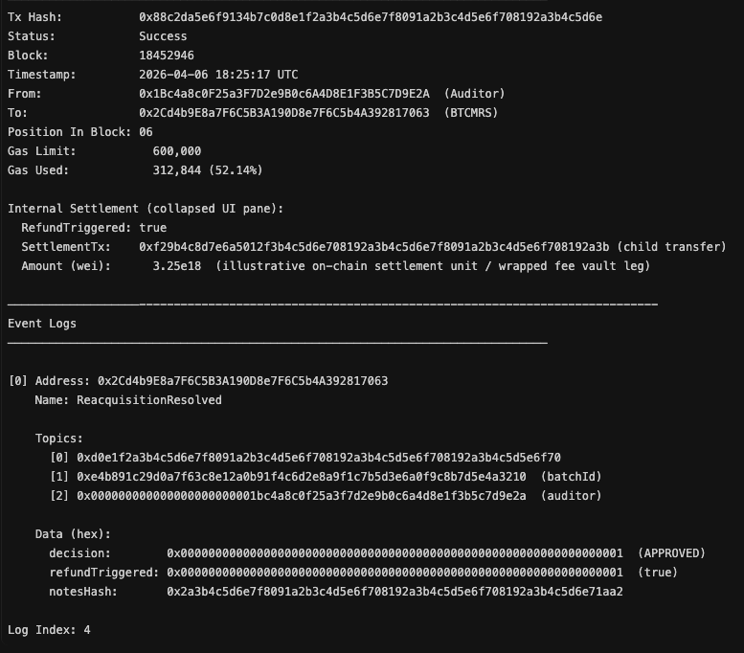
Figure 8. Comparative Gas Consumption of GeoZK-Miner Operations
The gas comparison confirms that the privacy-preserving verification stage introduces the largest runtime cost. However, this cost is justified because it provides the main security and privacy value of the framework. Without this verification step, the system would only provide ordinary blockchain traceability. With the region-based ZKP layer, GeoZK-Miner can support confidential mineral origin verification, which is especially important in conflict-sensitive mining environments.
The latency and throughput results provide another view of runtime performance. Lifecycle update and completion update achieved the highest throughput at 161.29 TPS, with average latency of 6.20 ms in the local Hardhat environment. Batch creation achieved 120.48 TPS, while reacquisition request achieved 64.94 TPS, with the highest average latency of 15.40 ms. The lower throughput of the reacquisition request is reasonable because the transaction stores a new governance request and associated reason information.
Figure 9 presents the average latency and throughput of the main runtime operations. The chart highlights that operations with greater state-writing requirements, such as reacquisition request and batch creation, show lower throughput than simpler lifecycle updates.
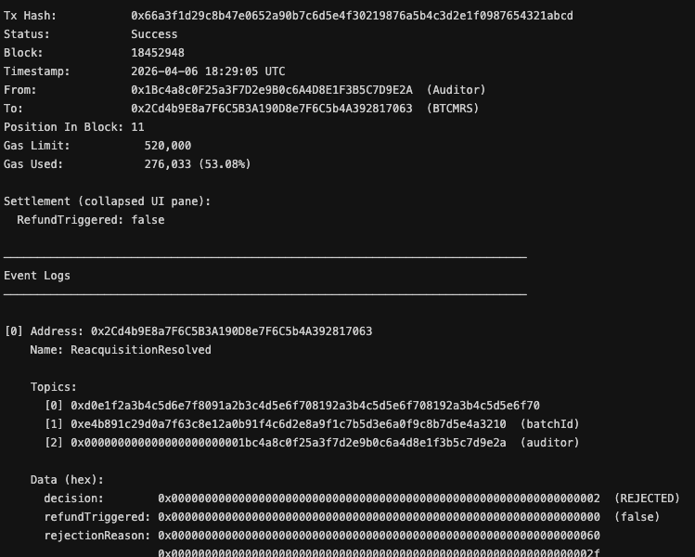
Figure 9. Average Latency and Throughput of GeoZK-Miner Operations
Overall, the runtime execution results demonstrate that GeoZK-Miner can execute its major workflow operations with measurable and predictable gas costs in a local Ethereum-compatible environment. The results also show a clear cost hierarchy. Simple lifecycle updates are the least expensive, reacquisition requests require moderate cost, batch creation requires higher cost due to initial provenance storage, and region-based ZKP verification is the most expensive because of cryptographic proof validation. This pattern is technically reasonable and supports the feasibility of the implemented framework.
It is important to note that the latency and throughput values are local Hardhat measurements. They should not be interpreted as public Ethereum throughput or production deployment results. Public networks introduce additional factors such as block time, transaction queueing, gas-price competition, and validator behaviour. Therefore, the results in this subsection should be understood as controlled implementation evidence rather than final production scalability measurements.
4.5 Region-Based ZKP Verification Analysis
The central privacy-preserving function of GeoZK-Miner is the region-based zero-knowledge proof. The implemented circuit verifies that private coordinates $\left(x , y\right)$, together with private randomness $r$, satisfy a geographic commitment and fall within an auditor-approved rectangular region. The public signals include region bounds, region hash, and commitment values. This allows the system to verify that a mineral batch originates from an approved region without publishing exact mine coordinates.
The current implementation verifies regional compliance only. Certification information is stored as a certificationHash during batch creation, but certification validity is not fully verified through the main ZKP path. This is an important implementation boundary. Therefore, GeoZK-Miner currently proves that a private location belongs to an approved region and matches the public commitment, while full ZKP-based certification-chain verification remains future work.Table 5 summarizes the main ZKP parameters and their privacy role.
Table 5 Region-Based ZKP Verification Parameters in GeoZK-Miner
Element | Implementation Detail | Privacy Role | On-chain / Off-chain Location
Private coordinates $\left(x , y\right)$ | Used as private witness inputs in the region circuit. | Exact mine location remains hidden. | Off-chain witness generation.
Private randomness $r$ | Used in the Poseidon-style geographic commitment. | Prevents direct recovery of location values from the commitment. | Off-chain witness generation.
Region bounds | Public values such as minX, maxX, minY, and maxY. | Defines the approved region policy without revealing the exact point. | Public proof signals / submitted verification data.
Region hash | Computed from the approved region bounds. | Binds the proof to an auditor-approved region. | Stored or checked on-chain.
Geographic commitment | Commitment generated from private coordinates and randomness. | Links the proof to a batch without revealing coordinates. | Stored on-chain as batch metadata.
Certification hash | Stored as a hash or commitment during batch creation. | Provides integrity reference for certification data. | On-chain hash; full certification ZKP not integrated.
Groth16 proof | Generated using Circom/snarkjs and verified through a Solidity verifier. | Confirms region membership without revealing private coordinates. | Proof generated off-chain; verification performed on-chain.
The ZKP workflow follows the common Circom/snarkjs pattern: compile the circuit, generate the witness, perform Groth16 proof generation, export verification data, and verify the proof through a Solidity verifier [22], [23]. The Ethereum-compatible verifier relies on pairing-check support associated with the alt_bn128 curve precompile described in EIP-197 [24].
The project logs also include transaction-level gas values for ZKP verification. These values represent full transaction receipt gas, including smart contract logic and event emission, not only the low-level pairing precompile.
Table 6 Gas Cost of Region-Based ZKP Verification
Transaction Hash | Block Number | Gas Used | Gas Limit / Context | Recorded Transaction Fee | Verification Result | Environment
0x4a4a685b6cfbcc570f82469955a033f84c81f942eb4b7d6685162eab22e688d7 | 65 | 293,548 | Gas limit not recorded in event log export | 0.000000076542641 ETH | true | Localhost / Hardhat
0x7fdee4002bb0482e5673e46bc9221534976144fe1988ce7047dd2b63d1cffd5d | 66 | 293,560 | 16,777,216 in enriched table export | 0.000000067071121 ETH | true | Localhost / Hardhat
The two ZKP verification examples show highly consistent transaction-level gas usage, approximately 293,500 gas. This indicates that region-proof verification has a predictable operational cost within the local environment. However, dedicated proof-generation time was not separately recorded in the current logs. Therefore, this paper reports on-chain verification gas and transaction-level latency, but does not claim a separate off-chain proof-generation benchmark.
Figure 4 presents the initial batch creation transaction in GeoZK-Miner, where a mining actor registers a new mineral batch on the local blockchain. The emitted MineralBatchCreated event records the batch identifier, mineral type, geographic commitment, and relevant batch metadata. The geographic commitment links the batch to private origin data without revealing the exact mine coordinates on-chain. In the recorded example, the transaction consumed 387,942 gas at block 18452937, establishing the first auditable provenance record for later ZKP verification, lifecycle tracking, and reacquisition governance.
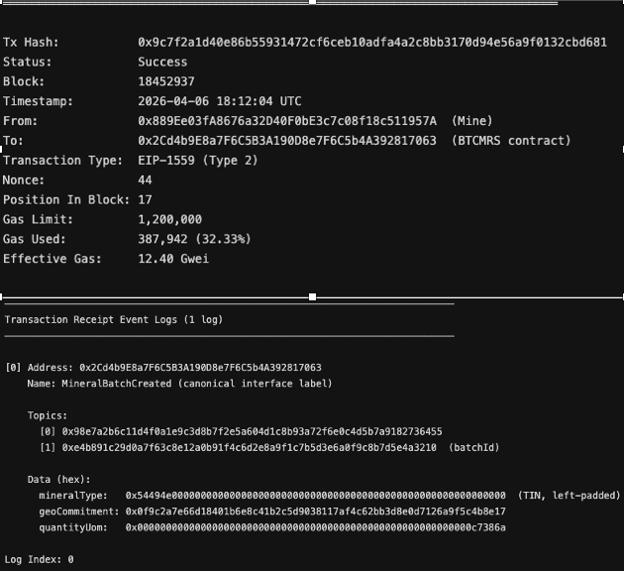
Figure 4. GeoZK-Miner Event Log: Batch Creation and Region-Based ZKP Verification
The verification process confirms the main technical contribution of GeoZK-Miner. A conventional blockchain traceability system can record where a batch is claimed to come from, but it may require sensitive location disclosure or trust in a central authority. In contrast, GeoZK-Miner allows the origin claim to be cryptographically checked through a zero-knowledge proof. This provides a stronger privacy-preserving provenance mechanism because the verifier receives evidence that the batch belongs to an approved region, while the precise coordinate values remain private.
However, the result should not be overgeneralized. The current implementation verifies only the region-membership condition and commitment consistency. It does not independently prove all certification-chain conditions through ZKP. Also, dedicated off-chain proof-generation time was not separately recorded in the current experimental logs. Therefore, this subsection reports on-chain verification gas and event-log evidence, while proof-generation benchmarking and full certification-proof integration remain future work.
4.6 Event Log and Audit Trail Analysis
The GeoZK-Miner prototype generates event logs to show how mineral batch activities are recorded during the provenance and reacquisition workflow. These logs provide implementation-level evidence that the smart contract records who triggered an action, which batch was affected, what event was emitted, and what information was stored in the transaction output. In this paper, these event logs are used as audit evidence from the local Hardhat environment. They should not be described as public Etherscan records unless the same transactions are later deployed and verified on a public testnet.
A complete GeoZK-Miner workflow can be understood as a sequence of blockchain events. First, a mineral batch is created and linked to a geographic commitment. Second, the region-based ZKP verification confirms that the batch satisfies the approved-region condition without exposing exact coordinates. Third, the batch moves through lifecycle or custody-related updates. Finally, if a downstream actor identifies a quality, provenance, or compliance issue, a reacquisition request is submitted and later resolved by an auditor.
Figure 5 illustrates the region-based zero-knowledge verification process in GeoZK-Miner. In this transaction, the auditor submits a verification call through the RegionProofVerifier contract to validate whether the mineral batch satisfies the approved-region condition. The transaction hash is recorded as 0x4bb602f17c19e4aa9f03c7d8822f6fa816c1e4d5a7b0e29384c55612adef90210, and the transaction is successfully executed at Block 18452939. The sender is the auditor address 0x18c4a0AF25a3F7D2e9R0C4dA0BE1F385C7D9F2A, and the receiver is the core GeoZK-Miner contract address 0x2Cd4b9E8a7F6C5B3A190D8e7F6C5b4A392817063. The transaction uses 2,936,120 gas, which represents 36.70% of the configured gas limit of 8,000,000. The event log records the ZKPVerified event with the proof hash, batch identifier, region identifier, verifier address, and verification result. The verification result is recorded as true, confirming that the submitted proof was accepted. This means the batch can be treated as originating from an approved mining region without revealing the exact private coordinates on-chain.
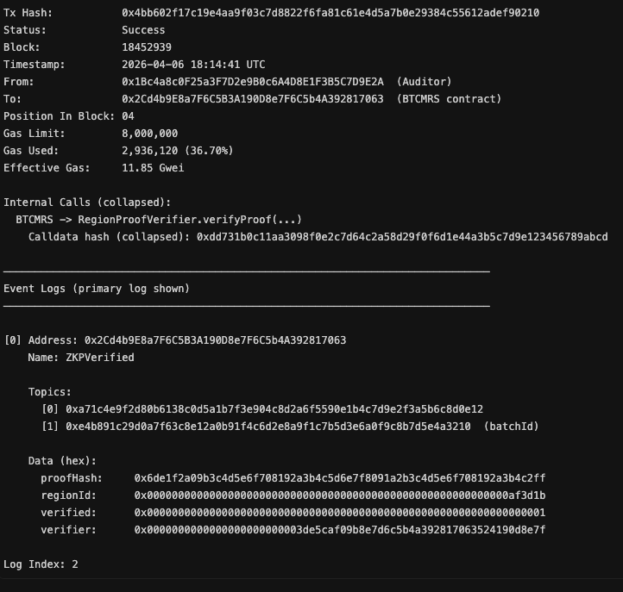
Figure 5. GeoZK-Miner Event Log: Region-Based ZKP Verification
Figure 6 presents the lifecycle or custody-related update stage in GeoZK-Miner. After a mineral batch has been created and region-verified, the framework records downstream movement or status progression through emitted lifecycle events such as BatchStatusUpdated or CustodyTransferred. In the recorded custody-update example, the transaction consumes 298,410 gas. This event provides an auditable checkpoint showing that the verified batch continued through the supply-chain workflow after successful proof verification. The log should be interpreted as implementation-level evidence of lifecycle progression rather than as a complete physical custody graph, because the exact meaning of sender, receiver, or location fields depends on the implemented contract structure.
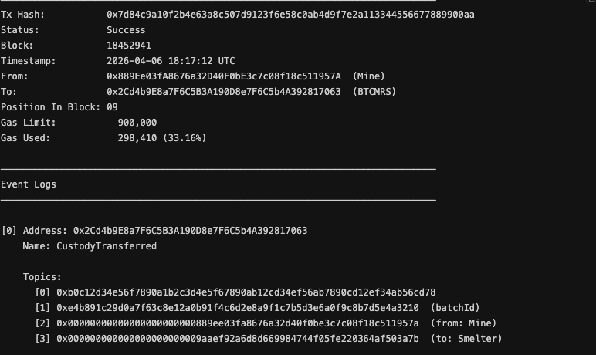
Figure 6. GeoZK-Miner Event Log: Lifecycle Status Update
Figure 7 demonstrates the reacquisition initiation process in GeoZK-Miner. In this transaction, the smelter initiates a formal ReacquisitionRequested event after identifying a quality or compliance concern. The transaction hash is recorded as 0x3e9a27d80461b5cf92a8e5d3074c1b6a0d3e7f9a2b4c6d8e0f193a5b7c9d1e2, and the transaction is successfully executed at Block 18452944. The sender is the smelter address 0x9AaEf92A6d8D669984744F05fe220364aF503A7B, and the receiver is the core GeoZK-Miner contract address 0x2Cd4b9E8a7F6C5B3A190D8e7F6C5b4A392817063. The transaction consumes 241,886 gas, representing 32.25% of the configured gas limit of 750,000. The event log records the batch identifier, requester address, reason code, and reason text. The reason code is 0x1, which corresponds to a quality-related deviation, and the reason text is “Quality deviation plus impurity”. This event is important because it marks the transition from ordinary provenance tracking to governance-based dispute handling. Once this request is recorded, the auditor can later review the case and resolve it through an approval, rejection, or audit-required decision.
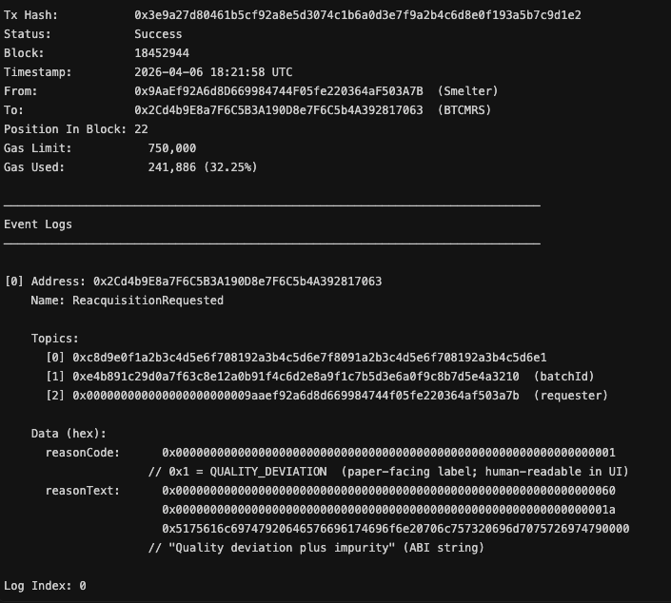
Figure 7. GeoZK-Miner Event Log: Reacquisition Request

Table 7
Event Logs Generated by GeoZK-Miner
Event Name | Triggering Operation | Main Data Recorded | Audit Value
RegionApproved | Auditor approves an eligible sourcing region. | Region hash, approving authority, timestamp. | Establishes which regions are accepted before batch verification.
BatchCreated | Mining actor creates a new mineral batch. | Batch identifier, creator, mineral type, geographic commitment, certification hash, timestamp. | Provides the initial provenance record for the mineral batch.
ZKPVerified | Auditor submits and verifies the region-based ZKP. | Batch identifier, verifier, verification result, proof-related gas field, timestamp. | Confirms that the batch passed regional origin verification without revealing exact coordinates.
BatchStatusUpdated | Authorized actor updates the batch lifecycle state. | Previous status, new status, updater, timestamp. | Records batch progression through the supply-chain workflow.
CustodyTransferred | Lifecycle or custody-related update is emitted. | Batch identifier, custody/location-related data, timestamp. | Supports the audit trail for batch movement, but interpretation depends on the implemented event fields.
ReacquisitionRequested | Smelter or manufacturer opens a reacquisition case. | Request identifier, batch identifier, requester, reason code, reason text, timestamp. | Creates a formal record that a batch has been challenged due to quality, provenance, or compliance concerns.
ReacquisitionResolved | Auditor resolves the reacquisition request. | Request identifier, batch identifier, decision, resolver, timestamp. | Provides the final governance decision for the disputed batch.
As summarized in Table 7, GeoZK-Miner records each major stage of the workflow as an auditable event. These events allow the lifecycle of a mineral batch to be reconstructed from creation to verification, downstream progression, reacquisition request, and final resolution. This event-driven design strengthens accountability because the system does not only store final outcomes; it also records the intermediate actions that led to those outcomes.

4.7 Performance Discussion
The implementation results demonstrate that GeoZK-Miner can execute its major provenance, verification, lifecycle, and reacquisition operations within measurable and predictable gas ranges in a local Hardhat environment. The purpose of this performance discussion is not to claim public Ethereum scalability, but to analyse the relative computational cost of each implemented operation and identify which parts of the framework create the highest execution overhead.
As reported in Table 4, ordinary lifecycle operations are the least expensive runtime actions in the prototype. The Lifecycle Update operation consumed an average of 76,874 gas, while the Completion Update consumed an average of 77,569 gas. These values are relatively low because these operations mainly update the batch status and emit state-transition events. They do not require complex proof verification or large new data structures.
By comparison, the Reacquisition Request operation consumed an average of 193,010 gas across the scripted benchmark runs. This higher value is expected because the operation creates a new governance record for a disputed batch. The contract must store the request identifier, batch reference, requester information, reason text, decision state, and timestamp. The individual event-log example shown in Fig. 7 consumed 241,886 gas, which is higher than the benchmark average. This difference is acceptable because the benchmark value represents repeated scripted measurements, while the figure represents one specific transaction with its own input length and execution context.
The Batch Creation operation consumed an average of 250,787 gas, making it one of the more expensive non-ZKP operations. This is technically reasonable because batch creation establishes the first provenance record for a mineral batch. The operation stores the mineral type, certification hash, geographic commitment, approved region reference, metadata, and initial state. Since this transaction creates the foundation for later verification and lifecycle tracking, its higher storage cost is expected.
The highest execution cost appears in the Region-Based ZKP Verification operation. The two recorded ZKP verification examples consumed 293,548 gas and 293,560 gas, respectively. This makes ZKP verification the most expensive runtime operation in the analysed outputs. The higher cost is expected because the verifier must validate a Groth16 proof and execute additional smart contract logic. However, this cost is also the most important privacy-preserving cost in the framework. Without this operation, GeoZK-Miner would only provide ordinary blockchain traceability. With it, the system can verify approved-region membership without exposing exact private mine coordinates.
Figure 8 compares the average gas usage of the major GeoZK-Miner operations. The figure illustrates a clear cost hierarchy: lifecycle and completion updates are the cheapest, reacquisition requests require moderate gas, batch creation requires higher gas, and region-based ZKP verification has the highest runtime gas cost.
Figure 8. Comparative Gas Consumption of GeoZK-Miner Operations
The latency and throughput measurements also show expected behaviour under local execution. The Lifecycle Update and Completion Update operations both achieved an average latency of 6.20 ms and throughput of 161.29 TPS in the local benchmark. Batch Creation achieved 8.30 ms average latency and 120.48 TPS. The Reacquisition Request operation recorded the highest average latency at 15.40 ms and the lowest throughput at 64.94 TPS. This pattern is reasonable because the reacquisition request operation performs more storage work than a simple status update.
Figure 9 presents the latency and throughput comparison for the main GeoZK-Miner operations. The figure illustrates that simpler lifecycle operations achieve higher throughput and lower latency, whereas reacquisition requests show lower throughput because they create additional governance records.
Figure 9. Average Latency and Throughput of GeoZK-Miner Operations
Overall, the performance results suggest that GeoZK-Miner is feasible as a prototype-level Ethereum-compatible framework. The gas values are consistent with the expected complexity of each operation. Simple status updates are lightweight, governance requests introduce moderate overhead, batch creation requires higher storage cost, and ZKP verification introduces the highest cost because of cryptographic validation. This cost structure is acceptable because the most expensive operation also delivers the main privacy-preserving contribution of the framework.
However, the results must be interpreted with clear limitations. All reported measurements were generated in a local Hardhat environment, not on public Ethereum, Sepolia, or mainnet. Therefore, the latency and throughput values should not be treated as production blockchain performance. Public deployment would be affected by block time, network congestion, gas-price competition, transaction queuing, and validator behaviour. In addition, the current logs do not separately record off-chain proof-generation time, so this study cannot claim a complete end-to-end ZKP timing benchmark. The current prototype also verifies region compliance only; certification validity is represented through a hash or commitment and is not fully verified through the main ZKP path.
Despite these limitations, the local results provide useful implementation evidence. They show that the proposed workflow can be executed, measured, and audited using smart contracts and event logs. They also show that the region-based ZKP verification cost is predictable across recorded transactions. This supports the practical feasibility of GeoZK-Miner as a foundation for privacy-preserving conflict mineral provenance and reacquisition governance.

4.8 Extended ZKP Evaluation and Scalability Scenario Analysis
To strengthen the evaluation of GeoZK-Miner without replacing the implementation results presented earlier, an extended ZKP-focused analysis was conducted. The purpose of this subsection is to provide additional evidence on repeated ZKP verification behaviour, gas-cost trends, response-time variation, and ZKP artefact size. While the earlier sections reported the core deployment, transaction execution, event logs, and individual ZKP verification examples, this subsection adds a broader evaluation view based on repeated verification and scenario-based scalability analysis.
The extended evaluation should be interpreted carefully. The results support the technical feasibility of the implemented prototype, but they should not be presented as public Ethereum mainnet performance. The experiments remain controlled evaluation outputs and should be understood as local or scenario-based evidence unless public testnet transaction receipts are explicitly provided. This distinction is important because production blockchain deployment may introduce additional factors such as gas-price fluctuation, mempool delay, block confirmation time, validator behaviour, and public network congestion.

4.8.1 Extended ZKP Verification Benchmark
The first part of the extended evaluation focuses on repeated ZKP verification. Since the earlier implementation section reported only a small number of ZKP verification examples, the extended benchmark improves the strength of the evaluation by repeating the verification process across 50 runs. This provides a more reliable basis for discussing average behaviour, variation, and gas predictability.

4.8.2 Gas-Cost Trend under Extended Transaction Scenarios
Figure 12 presents the gas-cost trend across cumulative GeoZK-Miner transactions. The figure compares the average gas behaviour of batch creation, ZKP verification, and reacquisition-related operations as the cumulative transaction count increases. The chart shows that batch creation remains comparatively lower than ZKP verification and reacquisition operations. ZKP verification maintains a higher gas-cost level because it involves cryptographic proof validation, while reacquisition operations also remain relatively expensive because they create and store governance-related dispute records.
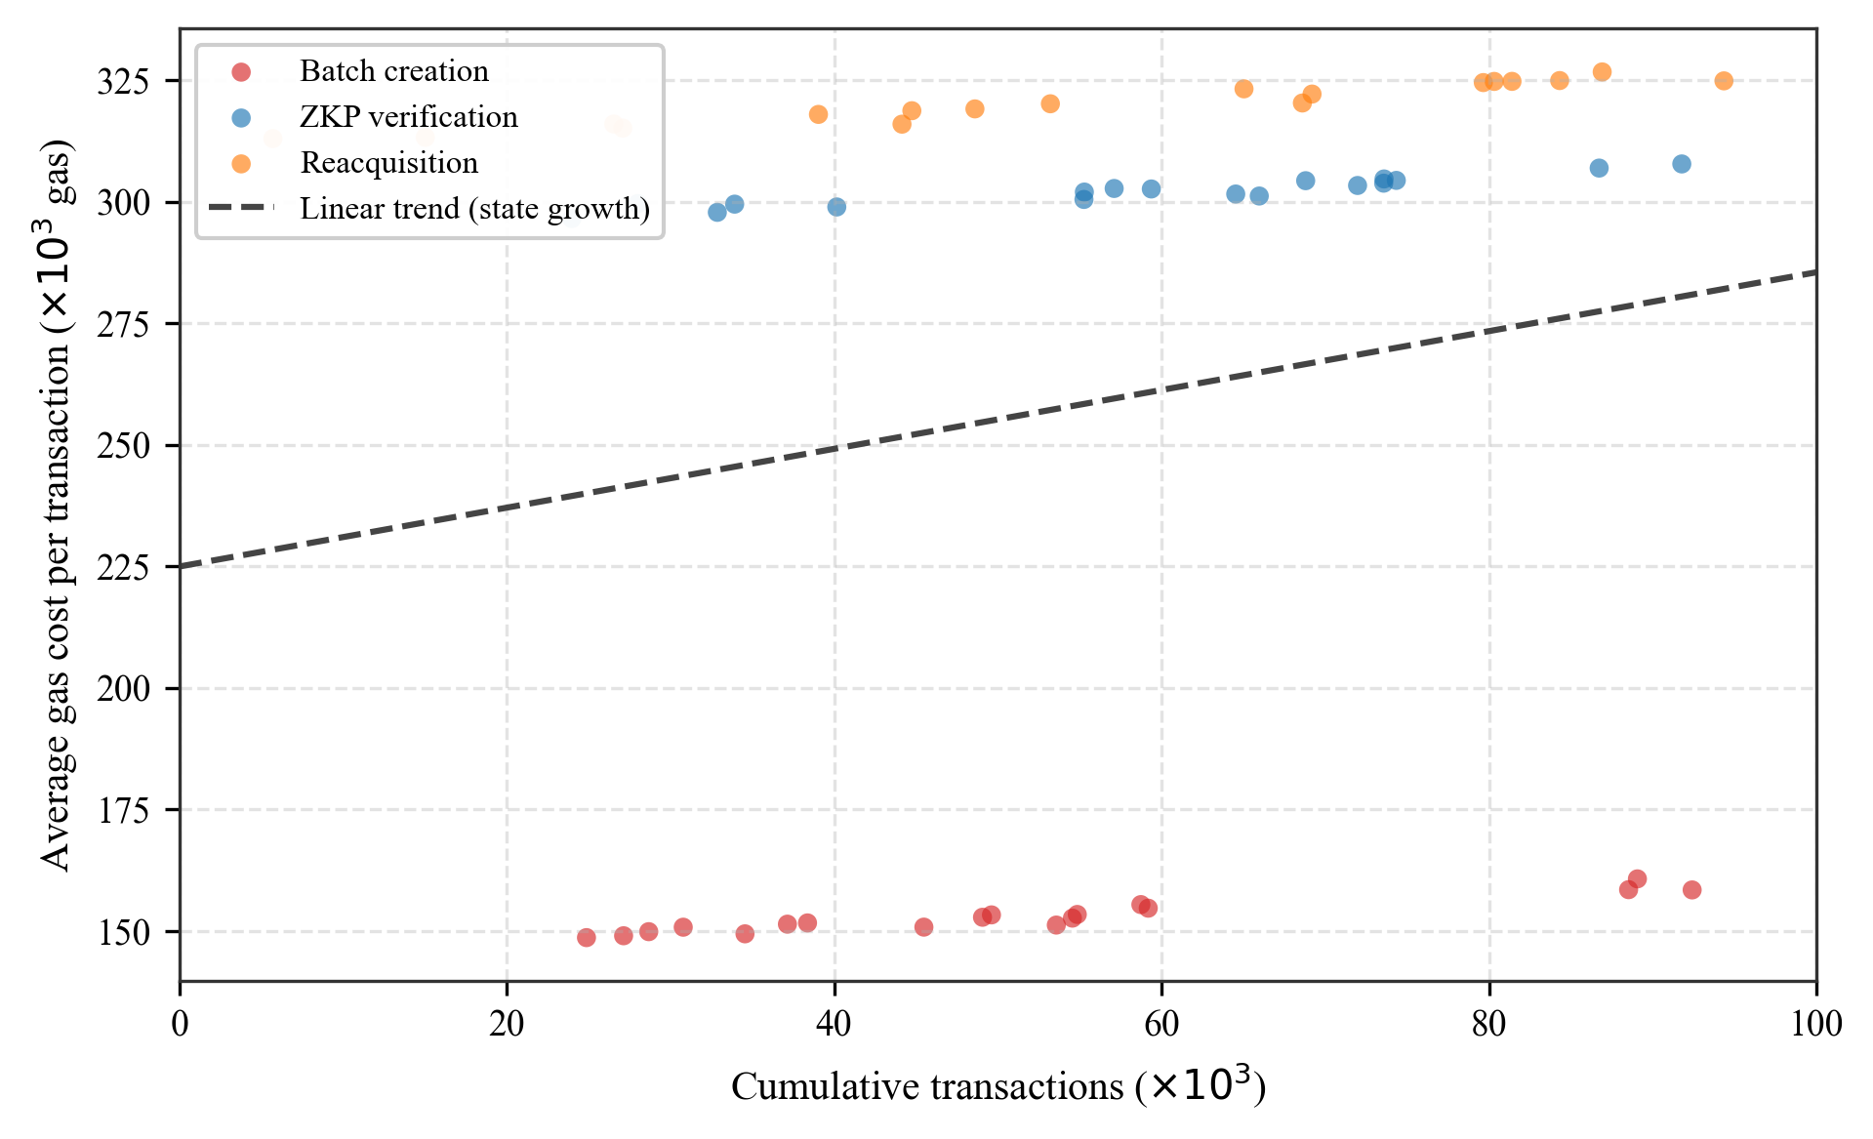
Figure 12. Gas Cost Trend across Cumulative GeoZK-Miner Transactions
The gas-cost trend provides useful insight into how the framework may behave as more transactions are processed. The upward trend suggests that state growth and repeated workflow execution can gradually increase operational cost per transaction. This highlights an important design consideration for future versions of GeoZK-Miner: the smart contract should minimise unnecessary on-chain storage, avoid redundant state updates, and consider batching, proof aggregation, or layer-2 deployment if the system is used at larger scale.

4.8.3 Response-Time Percentile Analysis
Figure 13 presents the response-time percentile analysis under increasing GeoZK-Miner workloads. Instead of reporting only average response time, this figure shows the median response time together with the 90th, 95th, and 99th percentile bands. This is useful because average response time can hide slower transactions. In supply-chain governance systems, occasional slow transactions may matter because delayed verification or reacquisition decisions can affect downstream operations.
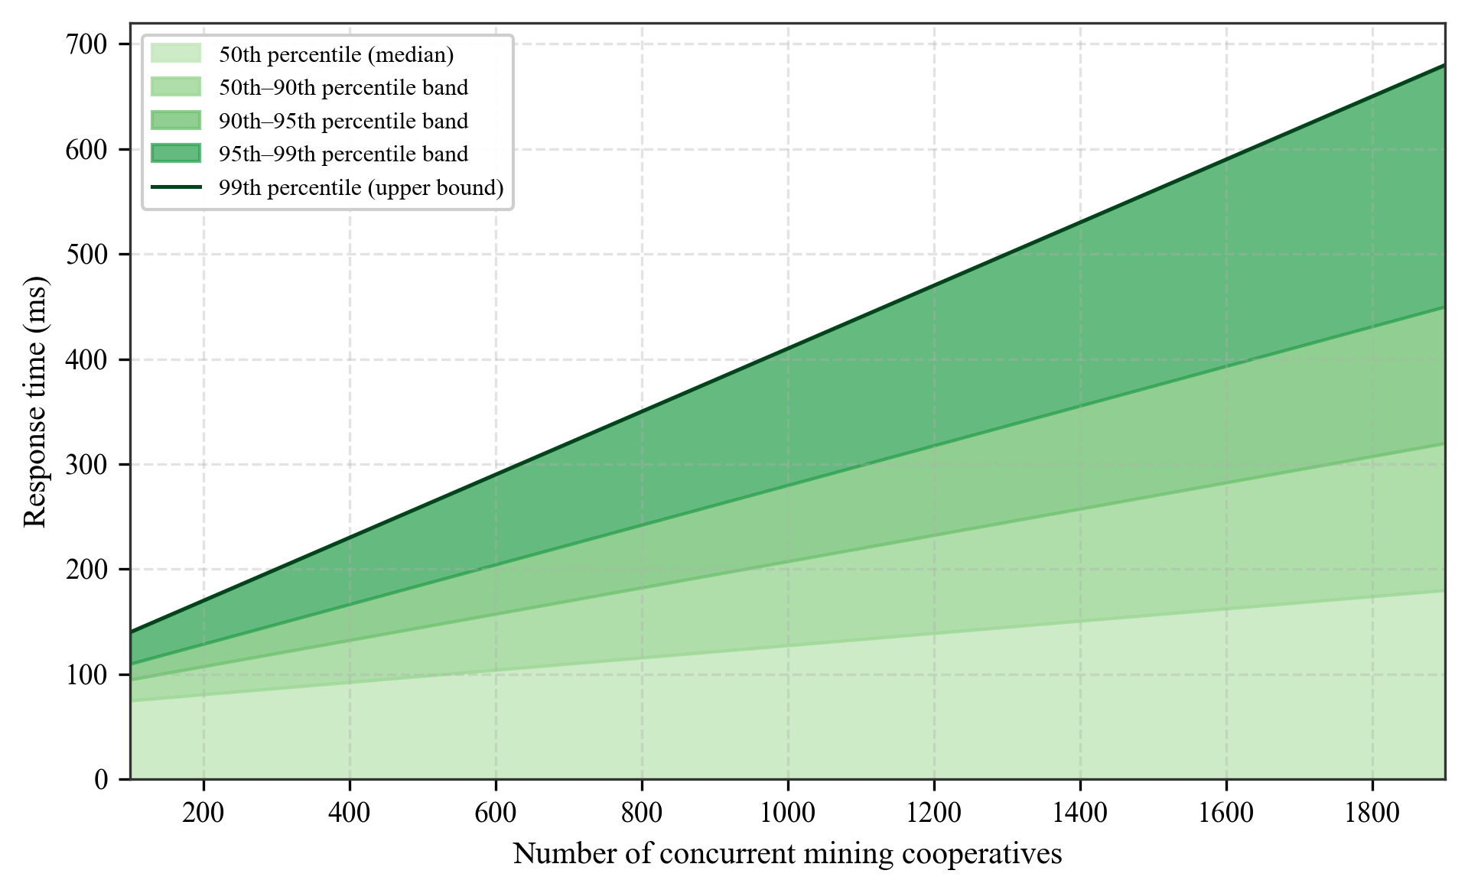
Figure 13. Response-Time Percentile Analysis under Increasing GeoZK-Miner Workloads
The percentile analysis shows that response time increases as the number of concurrent actors grows. The widening gap between the median and the 99th percentile indicates that higher-load conditions create greater variability and more extreme response-time cases. This suggests that larger deployments would require careful transaction management, batching, queue handling, or layer-2 scaling support. For an audit-oriented mineral provenance system, the 95th and 99th percentile values are particularly important because they represent slower cases that may affect operational responsiveness.
4.8.4 ZKP Artefact Size Analysis
ZKP systems should not only be evaluated through gas usage. They should also be assessed through artefact size because proof files, public signals, verification keys, proving keys, WASM files, R1CS binaries, and Solidity verifier source code all affect storage, portability, reproducibility, and deployment practicality. Figure 14 presents the ZKP artefact size analysis for GeoZK-Miner.
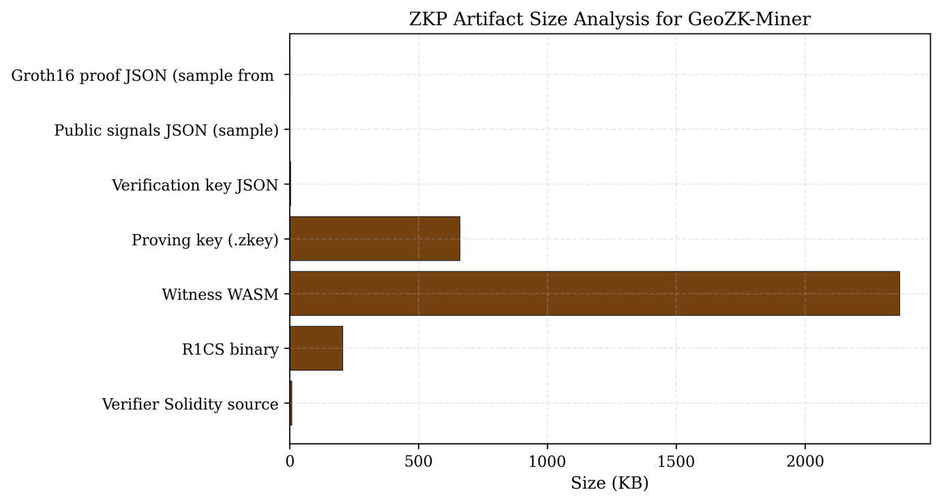
Figure 14. ZKP Artefact Size Analysis for GeoZK-Miner
The figure shows that the Witness WASM and proving key (.zkey) are the largest artefacts, while the proof JSON, public signals JSON, verification key JSON, and Solidity verifier source are comparatively smaller. This is expected in Groth16-based workflows because the proving key and witness-generation artefacts usually require more storage than the compact proof itself. From a deployment perspective, the proof and public signals are the most important runtime submission artefacts, while the larger proving artefacts are mainly needed off-chain by the prover.

4.8.5 Interpretation of Extended Evaluation Results
The extended evaluation strengthens the paper in three ways. First, the gas-cost trend provides a broader view of how major GeoZK-Miner operations may behave as transaction volume increases. Second, the response-time percentile analysis gives a clearer view of performance variability than simple average latency, especially under heavier workload assumptions. Third, the ZKP artefact size analysis adds practical evidence about the storage and deployment implications of using Groth16-based proof infrastructure.However, these results must be interpreted with clear boundaries. The extended evaluation does not prove production readiness on public Ethereum. It does not prove real-world stakeholder adoption. It also does not change the current implementation boundary: GeoZK-Miner verifies regional compliance through ZKP, while full certification-chain verification remains future work. Therefore, the safest interpretation is that the extended evaluation improves the prototype evidence and identifies scalability considerations, but does not replace the need for future public testnet evaluation, broader repeated benchmarking, and real-world validation.

5. Discussion, Comparative Analysis, and Deployment Readiness
This section discusses the broader significance of GeoZK-Miner in relation to existing conflict mineral traceability systems, blockchain-based provenance platforms, and zero-knowledge proof-enabled supply-chain frameworks. The implementation results in Section 4 demonstrate that the proposed framework can be realized as a working Ethereum-compatible prototype. This section now explains what those results mean from the perspective of privacy, ethical sourcing, governance, real-world deployment, and future scalability.

5.1 Comparative Discussion with Existing Traceability Approaches
Existing conflict mineral traceability approaches provide partial solutions to the problem of responsible mineral sourcing. Traditional systems such as iTSCi and manual bag-and-tag schemes support upstream due diligence, but they remain dependent on physical tags, manual records, institutional trust, and delayed verification [5], [6]. These systems help document mineral movement, but they do not provide cryptographic proof that a mineral batch originated from an approved region.
Blockchain-based mineral traceability platforms such as Circulor, Minespider, and IBM/RCS Global improve digital provenance by recording mineral movement and responsible sourcing information in tamper-resistant systems [15]–[18]. These systems demonstrate the usefulness of blockchain in mineral supply chains, but they generally rely on permissioned visibility or authorised data-sharing models. As a result, sensitive information such as supplier relationships, mine locations, and operational details may still need to be revealed to selected actors.Zero-knowledge proof-based supply-chain systems, including PrivChain and the work of Sahai et al., show that privacy-preserving verification is technically possible in blockchain-enabled supply chains [8], [10]. However, these works are not specifically designed for conflict mineral governance, regional mine-location privacy, or reacquisition handling. Similarly, BT-CSRS applies blockchain and ZKPs in the seafood supply-chain domain, but its focus is seafood sustainability, catching validation, and seafood reacquisition rather than conflict mineral provenance and exact coordinate protection [12].
GeoZK-Miner addresses this gap by combining three functions in one framework: region-based ZKP verification, blockchain-based mineral provenance, and smart contract-based reacquisition governance. This combination makes the framework more suitable for conflict mineral supply chains, where the system must prove ethical origin while also protecting sensitive mining locations.Figure 10 shows the comparative feature coverage of existing traceability approaches and GeoZK-Miner. The figure demonstrates that traditional traceability systems provide limited mineral traceability but lack blockchain support, ZKP integration, privacy-preserving verification, and reacquisition automation. Blockchain mineral platforms improve provenance support but provide only limited privacy-preserving verification. General ZKP supply-chain systems provide stronger privacy capability but are not mineral-specific. GeoZK-Miner achieves full feature coverage across the selected criteria because it integrates blockchain, ZKP, mineral traceability, and reacquisition governance in one framework.
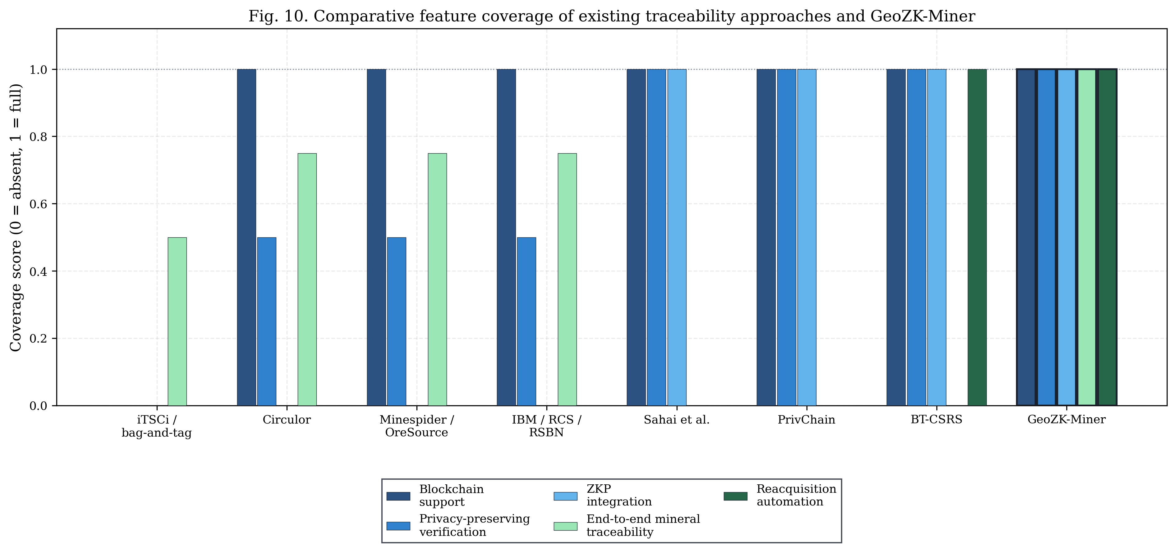
Figure 10. Comparative Feature Coverage of Existing Traceability Approaches and GeoZK-Miner.
To further support this comparison, Table 8 summarizes the positioning of GeoZK-Miner against major traceability and ZKP-enabled frameworks.

Table 8
Comparative Analysis of Existing Traceability Approaches and GeoZK-Miner
Approach / Framework | Main Domain | Blockchain Support | ZKP Support | Exact Coordinate Protection | Mineral-Specific Traceability | Reacquisition Governance | Main Limitation
iTSCi / bag-and-tag schemes [6] | Conflict minerals | No | No | No | Partial | No | Manual tagging, delayed reporting, and dependence on institutional trust.
Circulor [17] | Minerals and battery supply chains | Yes | No explicit support | Limited | Partial to broad | No explicit support | Improves digital traceability but does not provide region-based ZKP origin proof.
Minespider / OreSource [15], [16] | Mineral traceability and product passports | Yes | No explicit support | Limited | Partial to broad | No explicit support | Provides digital provenance but lacks cryptographic mine-location privacy.
IBM / RCS Global / RSBN [18] | Responsible mineral sourcing | Yes | No explicit support | Limited / permissioned | Broad | No explicit support | Focuses on validated data exchange rather than private region-proof verification.
Sahai et al. [10] | General supply chains | Yes | Yes | Partial | No | No | Demonstrates ZKP traceability but is not tailored to conflict minerals.
PrivChain [8] | General supply-chain provenance | Yes | Yes | Partial | No | No | Preserves privacy but does not address mineral-specific region verification or reacquisition.
BT-CSRS [12] | Seafood supply chain | Yes | Yes | No | No | Yes, seafood domain | Designed for seafood sustainability, not conflict mineral origin privacy.
GeoZK-Miner | Conflict minerals | Yes | Yes | Yes | Yes | Yes | Current prototype still requires public testnet validation and certification-ZKP extension.
The comparison shows that GeoZK-Miner is not simply another blockchain traceability model. Its contribution lies in adapting privacy-preserving verification to the conflict mineral context. In particular, the region-based ZKP mechanism allows the system to verify that a batch belongs to an approved mining region without exposing the exact extraction coordinates.

5.2 Research Gap Coverage and Novelty Positioning
The research gap addressed by this study is the absence of a framework that simultaneously supports tamper-resistant provenance, privacy-preserving verification, region-private mineral origin proof, smart contract lifecycle tracking, and reacquisition governance. Existing systems normally satisfy only some of these requirements. Traditional traceability schemes focus on documentation, blockchain mineral platforms focus on provenance recording, and general ZKP frameworks focus on privacy-preserving proof logic. However, none of these approaches fully integrates all requirements in a conflict mineral-specific framework.
To describe comparative coverage formally, let the feature support matrix be represented as:
$$M=[m_{ij}]$$
where $m_{ij}∈[0,1]$denotes the degree to which framework $i$supports capability $j$. A value of $1$indicates full support, $0.5$indicates partial support, and $0$indicates no clear support. The overall capability score of framework $i$can be written as:
$$Score_{i}=\frac{\sum_{j=1}^{n}{m_{ij}}}{n}$$
where $n$is the number of evaluated capabilities. This score is not intended to be a universal benchmark. Rather, it is a structured way to summarize the comparison criteria used in this study.
The coverage advantage of GeoZK-Miner can also be expressed as a gap reduction score:
$$GapReduction_{i}=1-\frac{\sum_{j=1}^{n}{(1-}m_{ij})}{n}$$
A higher value indicates that the framework addresses more of the identified research gaps. Since GeoZK-Miner supports all selected capabilities in the comparison model, its gap reduction score reaches the maximum value under the selected criteria.
Figure 11 presents the research gap coverage comparison across traceability framework categories. The heatmap shows that traditional traceability systems are weak in privacy, automation, and coordinate protection. Blockchain mineral platforms improve tamper-resistant provenance but remain limited in region-private proof. General ZKP systems offer strong privacy but are not designed for conflict mineral governance. GeoZK-Miner provides full coverage across all selected research gaps, including the key missing capability: region-private mineral origin proof.
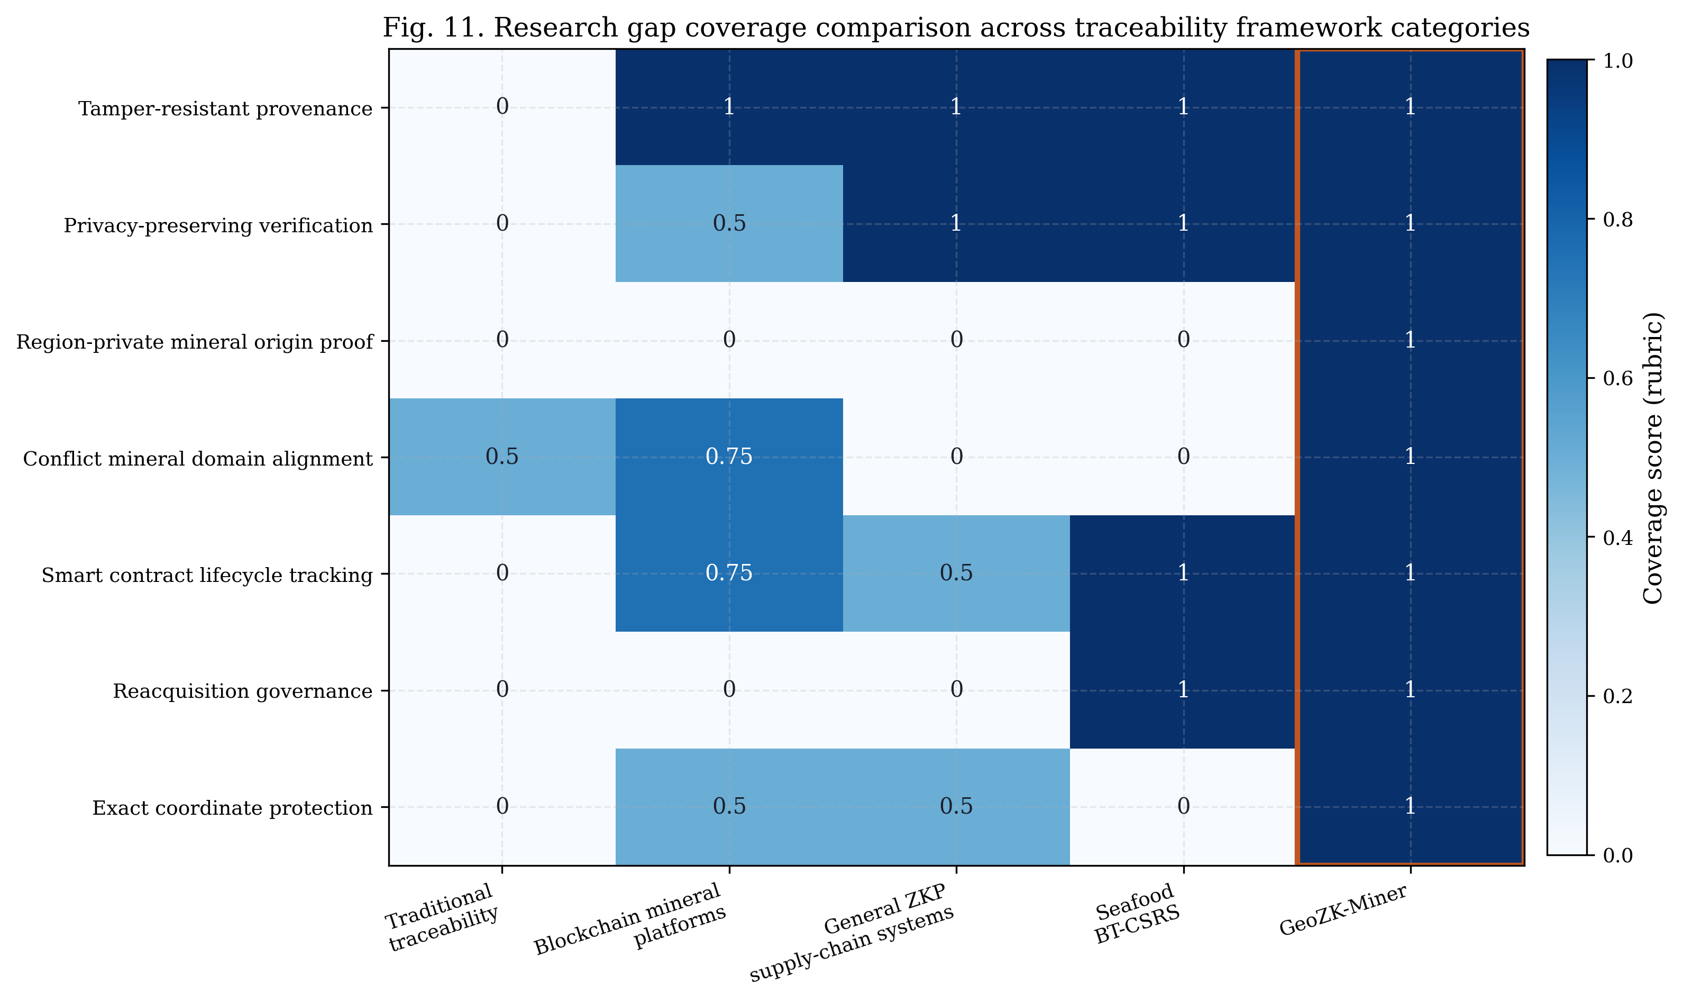
Figure 11. Research Gap Coverage Comparison Across Traceability Framework Categories.
The novelty of GeoZK-Miner therefore lies in domain-specific integration. The framework does not merely combine blockchain and ZKPs in a generic way. Instead, it applies privacy-preserving verification to the specific conflict mineral problem where exact coordinate disclosure may create security and commercial risks [5], [11].

5.3 Privacy, Integrity, and Governance Implications
The privacy benefit of GeoZK-Miner comes from separating private evidence from public verification evidence. The exact mine coordinates remain private, while the blockchain stores commitments, approved region references, verification outcomes, and event logs. This supports selective disclosure: downstream actors can verify that a batch satisfies the required sourcing condition without seeing the raw location data.
The integrity of the system can be described through event-chain accountability. Let the audit trail for a mineral batch be represented as:
$$A_{i}=\{e_{1},e_{2},…,e_{k}\}$$
where $A_{i}$is the audit trail for batch $i$, and each $e_{k}$represents a recorded event such as batch creation, ZKP verification, lifecycle update, reacquisition request, or reacquisition resolution. The completeness of the audit trail can be expressed as:
$$Completeness(A_{i})=\frac{∣E_{i}^{recorded}∣}{∣E_{i}^{required}∣}$$
where $E_{i}^{recorded}$is the set of events actually recorded for batch $i$, and $E_{i}^{required}$is the set of required events expected for a complete workflow. A higher completeness value indicates that more stages of the batch lifecycle are visible for audit review.
Governance enforcement can also be represented through role-based authorization. Let $Actor(a)$be the actor submitting a transaction and $Role(a)$be the assigned role of that actor. A transaction $Tx$for operation $op$is accepted only if:
$$Authorize(a,op)=\left\{\begin{matrix}1, & \text{if }Role(a)∈PermittedRoles(op) \\ 0, & \text{otherwise}\end{matrix}\right.$$
This means that sensitive actions such as region approval, proof verification, and reacquisition resolution can be restricted to auditors or authorised roles. The practical implication is that GeoZK-Miner is not only a data-storage system; it is also a rule-based governance mechanism.

5.4 Operational and Adoption Challenges
Although GeoZK-Miner demonstrates technical feasibility, moving from a local prototype to real-world deployment requires addressing several operational and institutional challenges. A suitable heading for this discussion is Operational and Adoption Challenges because the issue is not only technical deployment. The framework must also operate within real mining communities, regulatory structures, audit practices, and supply-chain relationships.
First, the current implementation was evaluated in a local Hardhat environment. This provides useful evidence of implementation correctness and relative gas cost, but it does not fully represent public blockchain conditions. A public deployment would introduce variable gas prices, confirmation delays, network congestion, and validator behaviour. Therefore, future evaluation should include public testnet experiments and stress testing under realistic conditions.
Second, GeoZK-Miner currently verifies regional compliance through ZKP, while certification validity is represented through a hash or commitment. This is useful for integrity referencing, but it does not prove the full certification chain. A production-ready version should include additional circuits for certificate validity, auditor signatures, expiry dates, and compliance status.
Third, approved-region governance is critical. The system can verify membership in an approved region, but it cannot independently decide whether the region itself has been ethically approved in a valid way. If the approved-region list is manipulated or poorly governed, then the proof verifies membership in a flawed region. Therefore, region approval must involve trusted auditors, regulators, or multi-party governance.
Fourth, physical-digital binding remains a challenge. GeoZK-Miner can secure the digital record, but it cannot automatically guarantee that the physical mineral batch has not been swapped, mixed, or mislabelled before registration. Future deployments should combine the framework with tamper-evident packaging, QR/NFC tags, IoT-assisted custody records, or independent inspection.
Fifth, adoption by artisanal and small-scale mining communities may require simplified interfaces and offline-friendly workflows. Many mine sites operate in low-connectivity environments, so the system must support delayed synchronization, mobile data entry, and cooperative-level operation rather than assuming constant internet access.

5.5 Practical Implications for Conflict Mineral Governance
GeoZK-Miner has practical implications for several stakeholder groups. For mining cooperatives, it provides a way to participate in digital traceability without exposing exact mine coordinates. This is important in conflict-affected regions where location disclosure may increase safety risks. For smelters and manufacturers, the framework provides stronger evidence that a batch is linked to an approved region. For auditors, it creates a structured record of region approval, ZKP verification, lifecycle progression, reacquisition request, and final resolution. For regulators, it supports a more transparent and auditable governance model.
The reacquisition mechanism is especially important because mineral supply chains do not always move in a simple forward direction. A batch may be challenged, rejected, quarantined, returned, or placed under further audit. Traditional systems often handle these cases manually. GeoZK-Miner formalizes this reverse workflow through smart contract events.
Let a reacquisition request be represented as:
$$RQ_{i}=\{ID_{i},ρ_{i},t_{i},a_{i}\}$$
where $ID_{i}$is the batch identifier, $ρ_{i}$is the reacquisition reason, $t_{i}$is the request timestamp, and $a_{i}$is the requesting actor.
The auditor decision can be represented as:
$$D_{i}∈\{Approved,Rejected,AuditRequired\}$$
A simplified decision function can be expressed as:
$$D_{i}=\left\{\begin{matrix}Approved, & \text{if the request evidence satisfies reacquisition conditions} \\ Rejected, & \text{if the request evidence is invalid or unsupported} \\ AuditRequired, & \text{if the evidence is incomplete or ambiguous}\end{matrix}\right.$$
This structure makes reacquisition governance auditable. The system records who raised the issue, why it was raised, which batch was affected, and how the auditor resolved the case. This provides stronger accountability than informal email-based or paper-based dispute handling.

5.6 Limitations
GeoZK-Miner has several limitations that should be acknowledged. First, the implementation was evaluated on a local Hardhat network. This means that gas values are useful for relative cost analysis, but latency and throughput values should not be treated as public blockchain performance. Future work should test the framework on public testnets and production-like environments.
Second, the current ZKP implementation verifies regional compliance but does not fully verify certification validity. Certification data is stored as a hash or commitment. This supports integrity checking, but it does not prove the full certification chain. Future work should introduce certification-specific ZKP circuits.
Third, the framework assumes that auditors correctly approve valid sourcing regions. If the approved-region list is inaccurate or compromised, then verification will only confirm membership in a flawed region. This means governance quality remains essential.
Fourth, the framework does not fully solve physical-digital binding. A secure blockchain record cannot by itself guarantee that the physical mineral batch has not been swapped or mixed. Therefore, real-world deployment should integrate physical security measures such as tamper-evident tags, QR/NFC labels, and independent inspection.
Fifth, the prototype does not separately measure full off-chain proof-generation time. The implementation reports on-chain verification cost and transaction-level behaviour, but future experiments should isolate witness generation, proof generation, and proof verification time.

5.7 Conclusion and Future Directions
This paper proposed GeoZK-Miner, a privacy-preserving blockchain framework for ethical mineral provenance and reacquisition governance. The framework addresses a key weakness in existing conflict mineral traceability systems: the need to prove responsible origin without exposing exact mine coordinates. By combining Ethereum-compatible smart contracts with region-based zero-knowledge proof verification, GeoZK-Miner allows a mining actor to prove that a mineral batch originates from an approved region while keeping the precise coordinate private.
The proposed framework also extends beyond ordinary forward traceability by introducing reacquisition governance. This allows disputed mineral batches to be formally requested for return, rejection, quarantine, or further audit through smart contract-controlled events. The implementation results demonstrate that the prototype can support batch creation, region-based ZKP verification, lifecycle progression, reacquisition request, auditor resolution, and event-log auditability in a local Hardhat environment.
Compared with traditional traceability systems, GeoZK-Miner reduces dependence on manual trust and paper-based records. Compared with blockchain-only mineral platforms, it improves privacy through region-based ZKP verification. Compared with general ZKP supply-chain frameworks, it is tailored to conflict mineral provenance and disputed batch governance.
Future work will focus on five directions. First, the framework should be deployed and tested on public testnets to evaluate realistic transaction latency, gas variation, and block confirmation behaviour. Second, the ZKP layer should be extended to verify certification validity, auditor signatures, certificate expiry, and compliance attributes. Third, the reacquisition workflow should support multi-auditor approval, richer evidence attachment, and dispute escalation. Fourth, physical-digital binding should be improved through secure QR/NFC tags, tamper-evident packaging, and IoT-assisted custody records. Fifth, the system should be extended with a user-facing dashboard for mining cooperatives, auditors, smelters, and regulators.
Overall, GeoZK-Miner provides a strong conceptual and technical foundation for privacy-aware conflict mineral traceability. It demonstrates that ethical provenance, location confidentiality, blockchain auditability, and reacquisition governance can be integrated into one framework. While further validation is needed before production deployment, the proposed model offers a forward-looking direction for responsible mineral sourcing in conflict-sensitive supply chains.
References

[1] | UN Security Council, ‘Final report of the Group of Experts on the Democratic Republic of the Congo [S/2024/432]’, Ecoi.net, 04-June-2024. [Online]. Available: https://www.ecoi.net/en/document/2112471.html. [Accessed: 23-May-2026].
[2] | ‘OECD Due Diligence Guidance for Responsible Supply Chains of Minerals from Conflict-Affected and High-Risk Areas’, Oecd.org. [Online]. Available: https://www.oecd.org/en/publications/2016/04/oecd-due-diligence-guidance-for-responsible-supply-chains-of-minerals-from-conflict-affected-and-high-risk-areas_g1g65996.html. [Accessed: 23-May-2026].
[3] | ‘Conflict Minerals’, Arcelormittal.com. [Online]. Available: https://corporate.arcelormittal.com/reports-and-policies/corporate-governance/conflict-minerals. [Accessed: 23-May-2026].
[4] | L. Feld, ‘A (Slight) Raise of the Bar: Due Diligence in the 2023 Update of the OECD Guidelines for Multinational Enterprises on Responsible Business Conduct’, Oecdwatch.org, 09-Nov-2023. [Online]. Available: https://www.oecdwatch.org/a-slight-raise-of-the-bar-due-diligence-in-the-2023-update-of-the-oecd-guidelines-for-multinational-enterprises-on-responsible-business-conduct/. [Accessed: 23-May-2026].
[5] | ‘Traceability of critical raw materials, with a focus on Africa’, Europa.eu. [Online]. Available: https://www.europarl.europa.eu/RegData/etudes/STUD/2025/754473/EXPO_STU(2025)754473_EN.pdf. [Accessed: 23-May-2026].
[6] | Itsci.org. [Online]. Available: https://www.itsci.org/wp-content/uploads/2024/09/ITSCI-Alignment-Assessment-report.pdf. [Accessed: 23-May-2026].
[7] | ‘Battery Supply Chain Traceability Market’, Futuremarketinsights.com. [Online]. Available: https://www.futuremarketinsights.com/reports/battery-supply-chain-traceability-market. [Accessed: 23-May-2026].
[8] | S. Malik, V. Dedeoglu, S. S. Kanhere, and R. Jurdak, ‘PrivChain: Provenance and privacy preservation in blockchain enabled supply chains’, in 2022 IEEE International Conference on Blockchain (Blockchain), 2022, pp. 157–166.
[9] | F. Longo, L. Nicoletti, A. Padovano, G. d’Atri, and M. Forte, ‘Blockchain-enabled supply chain: An experimental study’, Comput. Ind. Eng., vol. 136, pp. 57–69, 2019.
[10] | S. Sahai, N. Singh, and P. Dayama, ‘Enabling privacy and traceability in supply chains using blockchain and zero knowledge proofs’, in 2020 IEEE International Conference on Blockchain (Blockchain), 2020.
[11] | J. Ernstberger, C. Zhang, L. Ciprian, P. Jovanovic, and S. Steinhorst, ‘Zero-Knowledge Location Privacy via accurate floating-point SNARKs’, arXiv [cs.CR], 2024.
[12] P. Rani, P. Rani, I. Gupta, et al., 'BT-CSRS: A decentralized and distributed solution for sustainable seafood supply chain system utilizing zero-knowledge proofs and permissionless blockchain', Peer-to-Peer Netw. Appl., vol. 18, art. 311, 2025.

[13] S. Malik, V. Dedeoglu, S. S. Kanhere, and R. Jurdak, 'PrivChain: Provenance and privacy preservation in blockchain enabled supply chains', arXiv [cs.CR], arXiv:2104.13964, 2021. [Online]. Available: https://arxiv.org/abs/2104.13964. [Accessed: 23-May-2026].

[14] A. Mitani and A. Otsuka, 'Traceability in permissioned blockchain', IEEE Access, vol. 8, pp. 21573–21588, 2020.

[15] 'Case Study: LuNa Smelter', Minespider.com. [Online]. Available: https://www.minespider.com/case/luna-smelter. [Accessed: 23-May-2026].

[16] 'LuNa Smelter partners with Minespider, Google and Rwanda Mines to pilot OreSource blockchain tool', Minespider.com, 18-Nov-2020. [Online]. Available: https://www.minespider.com/press/luna-smelter-partners-with-minespider-google-and-rwanda-mines. [Accessed: 23-May-2026].

[17] 'Circulor Achieves First Ever Mine-to-Manufacturer Traceability of a Conflict Mineral Using Hyperledger Fabric — Tantalum from Rwanda Case Study', Lfdecentralizedtrust.org. [Online]. Available: https://www.lfdecentralizedtrust.org/case-studies/tantalum-case-study. [Accessed: 23-May-2026].

[18] 'Blockchain and sustainability through responsible sourcing — Responsible Sourcing Blockchain Network (RSBN)', Ibm.com. [Online]. Available: https://www.ibm.com/think/insights/blockchain-and-sustainability-through-responsible-sourcing. [Accessed: 23-May-2026].

[19] G. Kapnisakis, E. Kalogeropoulos, P. Sakellaropoulos, and N. Polyzos, 'A systematic literature review of blockchain-enabled supply chain traceability implementations', Sustainability, vol. 14, no. 4, art. 2439, 2022.

[20] 'Hardhat: Ethereum development environment for professionals', Hardhat.org. [Online]. Available: https://hardhat.org/docs/getting-started. [Accessed: 23-May-2026].

[21] 'Testing contracts — Hardhat Network', Hardhat.org. [Online]. Available: https://v2.hardhat.org/hardhat-runner/docs/guides/test-contracts. [Accessed: 23-May-2026].

[22] 'Circom 2 Documentation — Proving circuits with ZK', Docs.circom.io. [Online]. Available: https://docs.circom.io/getting-started/proving-circuits/. [Accessed: 23-May-2026].

[23] 'snarkjs: JavaScript implementation of zkSNARK and PLONK schemes', GitHub repository, iden3/snarkjs. [Online]. Available: https://github.com/iden3/snarkjs. [Accessed: 23-May-2026].

[24] V. Buterin and C. Reitwiessner, 'EIP-197: Precompiled contracts for optimal ate pairing check on the elliptic curve alt_bn128', Ethereum Improvement Proposals, no. 197, Feb. 2017. [Online]. Available: https://eips.ethereum.org/EIPS/eip-197. [Accessed: 23-May-2026].

[25] 'OpenZeppelin Contracts — Access Control', Docs.openzeppelin.com. [Online]. Available: https://docs.openzeppelin.com/contracts/5.x/access-control. [Accessed: 23-May-2026].

[26] 'OpenZeppelin Contracts — ReentrancyGuard', Docs.openzeppelin.com. [Online]. Available: https://docs.openzeppelin.com/contracts/5.x/api/utils#ReentrancyGuard. [Accessed: 23-May-2026].

[27] V. Buterin, E. Conner, R. Dudley, M. Slipper, I. Norden, and A. Bakhta, 'EIP-1559: Fee market change for ETH 1.0 chain', Ethereum Improvement Proposals, no. 1559, Apr. 2019. [Online]. Available: https://eips.ethereum.org/EIPS/eip-1559. [Accessed: 23-May-2026].

